FLAIRE: Offline-First Flood Early Warning System Using LoRa Sensors for Brgy. Elvita, Narra, Palawan

An Undergraduate Thesis
Presented to the faculty of the
Occidental Cluster-Narra Campus
Palawan State University

In Partial Fulfillment of the
Requirements for the Degree
Of Bachelor of Science in Computer Science

By

Betita, Nathaniel S.
Cabotaje, Jon David
Gabo, Dreext
Hamad, Summer
Unos, Ikram

January 2026

APPROVAL SHEET

This thesis is entitled “FLAIRE: OFFLINE-FIRST FLOOD EARLY WARNING SYSTEM USING LORA SENSORS FOR BRGY. ELVITA, NARRA, PALAWAN” prepared and submitted by Nathaniel S. Betita, Jon David Cabotaje, Dreext Gabo, Summer Hamad, and Ikram Unos in partial fulfilment of the requirements for the degree of Bachelor of Science in Computer Science, is hereby accepted.

JOEL P. GULANE JR., MIT
Research Adviser

PANEL OF EXAMINERS

Approved by the Panel on Oral Thesis/ Defense Examination with a grade of _____________.

JUAN MIGUEL B. RODRIGUEZ
Chairperson

EARL ASI M. MARTINEZ ERROL A. FUERTES
Member Member

Accepted and approved in partial fulfilment for the degree of Bachelor of Science in Computer Science.

REMEDIOS L. MAGBANUA, MAEd
Campus Director

Date: _______________

ACKNOWLEDGEMENT

Abstract
Betita, Nathaniel S. “FLAIRE: OFFLINE-FIRST FLOOD EARLY WARNING SYSTEM USING LORA SENSORS FOR BRGY. ELVITA, NARRA, PALAWAN”

Flooding threatens rural riverbank communities in the Philippines, where warnings rely on manual observation and advisories that may miss local conditions. This study designed and evaluated FLAIRE (Flood Level AI Risk Evaluation), an offline-first hybrid Fuzzy-AI early-warning system for Brgy. Elvita, Narra, Palawan, combining LoRa sensors, cached weather and tide forecasts, and a two-stage AI pipeline on a Raspberry Pi 5. A Random Forest model estimates flood propensity (Low, Medium, High) from eight weather and tidal features; a 20-rule fuzzy-logic classifier fuses it with real-time water level, rate of rise, rainfall, and tide into four risk levels: Receding, Alert, Alarm, Critical.
Trained on 1,826 daily records (2020-2024) from PAGASA and NAMRIA and tested on a held-out 20% set, the Random Forest reached 94.26% accuracy (F1: 0.97, 0.91, 0.92); as labels were rule-derived, this reflects agreement with the scoring rule, not independent validation. A check of four documented flood events classified two as High and two as Medium; rule-derived labels capture accumulated-rainfall signals but do not reliably encode flood occurrence. A field deployment logged 13,568 LoRa records over 21.5 h, but anomalies and battery depletion confined testing to Receding conditions, leaving higher classes unvalidated. Two BDRRMC focal persons rated it favorably (5.00 on functionality, reliability, preparedness, attitude, and intention to use). Findings demonstrate feasibility of an offline-first, edge-based flood decision-support system while identifying sensor, power, and validation improvements needed before deployment.

Table of Contents
Page
Approval Sheet ii
Acknowledgement iii
Abstract iv
Table of Contents v
List of Tables vii
List of Figures viii
List of Abbreviation and/or Symbols ix
Chapter 1: Introduction 1
Background of the Study 1
Statement of the Problem 4
Significance of the study 5
Scope and Delimitations 6
Definition of Terms 8
Chapter 2: Theoretical Framework 10
Review of Related Literature 10
Review of Related Studies 17
Conceptual Framework 24
Research Paradigm 25
Chapter 3: Research Methodology 27
Research Design 27
Locale of the Study 28
Flowchart of the Proposed System 29
Target Respondents 34
Instrumentation 34
Gantt Chart 35
Cost and Benefits Analysis 36
System Maintenance Plan 39
Developer and Client Communication 39
Chapter 4: Results And Discussion 41
Chapter 5: Summary Of Findings, Conclusions, And Recommendations 42
References 43
Bionotes 47
Appendices 48

List of Tables
Page
Table 3.1 Fuzzy-logic decision rules 36
Table 3.2 Cost Analysis 36
Table 4.1 Current flood warning practices, limitations, and data sources
Table 4.2 Random Forest performance on the held-out test set
Table 4.3 Representative fuzzy-logic inputs and outputs for each risk class
Table 4.4 Random Forest output for the four documented flood events
Table 4.5 Preliminary sensor-data quality findings
Table 4.6 Initial acceptability ratings from BDRRMC focal persons

List of Figures
Page
Figure 2.1. Schematic presentation of conceptual framework 27
Figure 3.1. DRM Framework 28
Figure 3.2. Locale of the Study 30
Figure 3.3.1. LoRa-enabled Hydrological sensor node flowchart 31
Figure 3.3.2. Edge device flowchart 32
Figure 3.3.3. LAN Dashboard 34
Figure 3.4. Gantt Chart 37

List of Abbreviation and/or Symbols
AI | Artificial Intelligence
ANN | Artificial Neural Network
API | Application Programming Interface
ASTI  BDRRMC | Advanced Science and Technology Institute  Barangay Disaster Risk Reduction and Management Committee
CSU-MLP | Colorado State University Machine Learning Probabilities system
DIMER | Decentralized Intelligent Model Exchange Repository
DNN | Deep Neural Network
DOST | Department of Science and Technology
DRM  DRRM | Design Research Methodology  Disaster Risk Reduction Management
EW4A | Early Warnings for All
EWS4 | Flood Forecasting and Early Warning System for the Greater Metro Manila and Laguna Lake Complex Project.
FFEWS | Flood Forecasting and Early Warning System
FLAIRE | Flood Level AI Risk Evaluation
GRU | Gated Recurrent Unit
GSM | Global System for Mobile communications
HEC‑HMS | Hydrologic Engineering Center – Hydrologic Modeling System
ICT | Information and Communications Technology
IoT | Internet of Things
IPO | Input-Process-Output
ITU | International Telecommunication Union
KoICA | Korea International Cooperation Agency
LAN | Local Area Network
LoRa | Long Range
LoRaWAN | Long Range Wide Area Network
LSTM | Long Short-Term Memory
MDRRMO | Municipal Disaster Risk Reduction Management Office
MHEWS | Multi-Hazard Early Warning Systems
ML | Machine Learning
NAMRIA | National Mapping and Resource Information Authority
NDRRMP | National Disaster Risk Reduction and Management Plan
NRMSE | Normalized Root Mean Square Error
NSE | Nash-Sutcliffe Efficiency
PAGASA | Philippine Atmospheric, Geophysical and Astronomical Services Administration
PBDHM | Physically‑Based Distributed Hydrological Model
PBIAS | Percentage Bias
PIN | People in Need
PSU | Palawan State University
RBMES | Results‑Based Monitoring and Evaluation System
R&D | Research and Development
SMS | Short Message Service
SOM | Self‑Organizing Map
SVM | Support Vector Machine
TC | Tropical Cyclone
UN | United Nations
WRF | Weather Research and Forecasting Model

Chapter 1

INTRODUCTION

Background of the Study
Flooding is one of the most common and devastating natural disasters worldwide, affecting millions of people annually and causing significant economic losses, infrastructure damage, and loss of life. In the Philippines, flooding remains a persistent threat because of the country’s geographic location, tropical climate, and seasonal monsoon patterns. Rural communities situated along riverbanks are particularly vulnerable to riverine flooding, which occurs when rivers overflow their banks due to excessive rainfall, upstream runoff, or prolonged precipitation.
Brgy. Elvita, located in the Municipality of Narra, Palawan, is a flood-prone community that experiences seasonal riverine flooding during the monsoon and typhoon seasons. The barangay has been identified by the Provincial Disaster Risk Reduction and Management Council as one of the more flood-vulnerable areas in Palawan, which contributed to its selection as a pilot site for a provincial Flood Early Warning System (FEWS) installation (Radyo Natin Nationwide, 2020). Provincial and local reports indicate that Brgy. Elvita and its adjacent communities have repeatedly experienced flooding that inundates agricultural lands for extended periods, causing economic disruption and placing lives and property at risk. The barangay’s proximity to a major river system, combined with limited structural flood-mitigation works, unreliable internet connectivity, and continued reliance on threshold-based warning practices, exposes residents to persistent flood risk. In many rural settings such as Brgy. Elvita, traditional flood-warning approaches depend largely on manual river observation, water-level thresholds, and reactive alert mechanisms, which may not consistently provide sufficient lead time for effective evacuation and preparedness.
Current flood-warning approaches in many Philippine barangays face several important limitations. Numerous rural communities depend on manual monitoring by Barangay Disaster Risk Reduction and Management Committees (BDRRMCs), which can be labor-intensive and prone to delays or human error. Traditional threshold-based systems often trigger alerts only when water levels exceed predetermined limits, with limited consideration of forecast rainfall, tide conditions, or the rate of water-level increase. In addition, existing Flood Early Warning Systems deployed by the Department of Science and Technology–Advanced Science and Technology Institute (DOST-ASTI) transmit sensor data to centralized servers, where it is accessed by disaster risk reduction and management personnel through web-based platforms. However, access to these systems may be limited during network outages, which are common in rural areas during typhoons. As a result, many existing systems provide limited predictive capability for anticipating flood risk hours or days in advance, reducing the lead time available for communities to prepare and respond. These limitations underscore the need for offline predictive decision-support tools that can use local hydrological and meteorological data even when internet connectivity is unavailable.
Recent advances in Internet of Things (IoT) technologies, wireless sensor networks, and artificial intelligence offer promising opportunities to address these limitations. LoRa (Long Range) wireless communication supports the deployment of low-power sensor nodes that can transmit real-time water-level and rainfall data from remote river locations to a local edge device without requiring internet connectivity. Cached weather and tide forecast data, pre-downloaded at least daily (every six hours) when internet is available through services such as OpenMeteo, can provide rainfall predictions, temperature extremes, and tide levels that complement ground-based sensor observations stored in a local database. Machine learning and fuzzy-logic systems can then run entirely on local edge hardware to analyze these multi-source inputs and estimate flood risk with improved lead time compared with purely threshold-based approaches.
Despite these technological advancements and the presence of national and regional flood-forecasting initiatives in the Philippines, there are still relatively few documented implementations that combine cached weather and tide forecasts, real-time river-sensor measurements, hybrid AI analytics using Random Forest and fuzzy logic on local hardware, and offline-capable alert dissemination within a single modular offline-first architecture tailored for rural barangay-level deployment. Moreover, there is limited empirical research at the barangay scale that systematically evaluates such hybrid AI-based flood-risk classification systems in the Philippine context.
This study addresses these gaps by designing and developing FLAIRE (Flood Level AI Risk Evaluation), an offline-first hybrid Fuzzy-AI riverine flood-risk classification and early-warning system tailored for Brgy. Elvita, Narra, Palawan. FLAIRE collects real-time water-level measurements and rainfall amount from a LoRa-based hydrological sensor node deployed along the river and transmit them to a Raspberry Pi 5 edge device. At the edge device, the Random Forest model analyzes historical and forecast meteorological and tide features, R1, R3, R7, rain_days, TMAX, TMIN, TideMax, and TideMin, to estimate flood propensity. The fuzzy-logic classifier then integrates this propensity with the real-time water-level reading, its rate of rise, the cached forecast rainfall, and the tide level to generate four flood-risk levels: Receding, Alert, Alarm, and Critical, drawing on cached forecasts up to seven days ahead.
By combining real-time LoRa sensor data, cached weather and tide information, locally executed Random Forest and fuzzy-logic classification, and offline-capable SMS and dashboard alerts, this study aims to demonstrate a practical, scalable, and internet-independent approach to barangay-level flood early warning, and to explore whether machine-learning models can be used to assist in assessing flood risk at the barangay scale. The resulting system can be scientifically evaluated and, if proven effective, potentially adapted for other flood-prone communities across the Philippines.

Statement of the Problem
Specifically, this study seeks to answer the following questions:
- What are the key problems and limitations in current flood-warning practices and data utilization in Brgy. Elvita, Narra, Palawan, and how can these be addressed through an offline-first, AI-based flood early-warning system?
- How can a Fuzzy-AI riverine flood-risk classification system be designed and developed for Brgy. Elvita that integrates the following components?
  - Cached seven-day weather and tide forecast data from OpenMeteo, updated at least daily (every six hours) when internet connectivity is available and stored in a local database;
  - Real-time water-level and rainfall data from a LoRa-based hydrological sensor node transmitted to a Raspberry Pi 5 edge device;
  - A hybrid AI pipeline in which a Random Forest model estimates flood propensity using R1, R3, R7, rain_days, TMAX, TMIN, TideMax, and TideMin, while a fuzzy-logic classifier with 20 rules (a 15-rule core plus 5 gap-fill rules) integrates this propensity with the real-time water-level reading, its rate of rise, the cached forecast rainfall, and the tide level to classify flood risk as Receding, Alert, Alarm, or Critical using cached weather and tide forecasts; and
  - A local web dashboard accessible through a local area network (LAN), enabling BDRRMC personnel to monitor real-time sensor data, AI-based risk classifications, and visualizations without internet connectivity, with alerts delivered through the dashboard and SMS?
- How consistently does the Random Forest flood-propensity model reproduce the rule-derived Low, Medium, and High flood-propensity categories on a held-out test set, in terms of accuracy, precision, recall, and F1-score?
- How did the FLAIRE prototype perform during a limited field deployment in terms of sensor-data capture, data logging, and data quality?
- How acceptable is the developed FLAIRE system to the BDRRMC focal persons of Brgy. Elvita, Narra, Palawan in terms of functionality, usability, reliability, perceived contribution to disaster preparedness, attitude toward use, and intention to use, as measured through a Technology Acceptance Model (TAM)-based interview or survey?

Significance of the study
This study provides practical value to the Barangay Disaster Risk Reduction and Management Committee (BDRRMC) of Brgy. Elvita by delivering an offline-first, AI-enhanced flood early-warning system that generates flood-risk classifications from real-time sensor data and cached forecasts. Through a LAN-accessible web dashboard, the system supports informed decision-making, preemptive evacuation planning, and resource allocation even during internet or power interruptions. Barangay officials and residents may also benefit from timely flood notifications through SMS alerts and dashboard-based monitoring, improving community preparedness and resilience in a flood-prone, low-connectivity setting.
The hybrid design of FLAIRE is particularly beneficial at the barangay level. The Random Forest model provides data-driven estimates of flood propensity based on historical and forecast meteorological and tide-related features, while the fuzzy-logic classifier integrates these estimates with the real-time water-level reading, its rate of rise, the cached forecast rainfall, and the tide level using interpretable decision rules. This approach allows BDRRMC personnel to understand not only the resulting risk level, Receding, Alert, Alarm, or Critical, but also the local conditions and decision logic that contributed to it. Because the final warning decision remains with the BDRRMC, the system functions as a decision-support tool rather than a replacement for human judgment.
Academically, the study contributes a documented, reproducible implementation of an offline-first hybrid Random Forest and fuzzy-logic flood-risk classification system for a rural Philippine barangay, together with an honest account of its limitations. The study demonstrates the integration of multi-source data, including LoRa-based sensor measurements and cached weather and tide forecasts, within an offline-first architecture suitable for rural Philippine barangays. It also documents that the Random Forest was evaluated for consistency with a rule-derived scoring scheme rather than validated against independent flood events, and it identifies the labeling and validation steps required to establish real predictive skill.
On a policy level, the findings support the feasibility of barangay-scale flood early-warning systems that can operate with minimal internet dependency and use edge-based AI for local decision-making. The results may inform future investments in scalable, low-cost, and power-resilient monitoring systems for flood-prone communities across the Philippines. While the pilot deployment was limited in duration and local conditions, its findings can serve as an initial basis for refining FLAIRE and guiding future longer-term validation in similar community settings.

Scope and Delimitations
This study focuses on the design, development, and pilot deployment of FLAIRE (Flood Level AI Risk Evaluation), an offline-first hybrid Fuzzy-AI riverine flood-risk classification and early-warning system, exclusively in Brgy. Elvita, Narra, Palawan. The study targeted a specific river section identified as vulnerable to riverine flooding. It excludes coastal flooding, flash floods in upstream mountainous areas, and flood risks outside the barangay boundaries.
FLAIRE is designed to integrate historical, forecast, and real-time data so that cached forecasts can be reused when connectivity is unavailable. Historical meteorological and tide-related data were obtained from PAGASA and NAMRIA, while cached forecast weather and tide data were retrieved from the Open-Meteo API; local flood occurrence information and field observations were obtained from the Barangay Disaster Risk Reduction and Management Committee (BDRRMC) and related local records. Where localized data are limited, preprocessing and feature-engineering techniques were applied to construct a usable dataset for model development and evaluation. All system data were stored in a local SQLite database for model training, validation, dashboard operation, and field-test analysis.
Real-time hydrological data were collected using a LoRa-based sensor node equipped with an ultrasonic water-level sensor and a rain gauge, deployed along the selected river section. Sensor data were transmitted through LoRa to a Raspberry Pi 5 edge device. Cached seven-day weather and tide forecast data from the OpenMeteo API were updated at least daily (every six hours) whenever internet connectivity was available and stored locally for offline use.
The system used a hybrid Random Forest and fuzzy-logic classification approach. The Random Forest model estimated flood propensity using R1, R3, R7, rain_days, TMAX, TMIN, TideMax, and TideMin. The fuzzy-logic classifier, composed of 20 rules (a 15-rule core plus 5 gap-fill rules), integrated the Random Forest output with the real-time water-level reading, its rate of rise, the cached forecast rainfall, and the tide level to generate four standardized flood-risk levels: Receding, Alert, Alarm, and Critical.
System outputs were accessible through a LAN-based web dashboard hosted on the Raspberry Pi 5 edge device. The dashboard allowed BDRRMC personnel to monitor real-time sensor data, AI-based risk classifications, and system visualizations without internet connectivity. The system also supported SMS notifications for key barangay officials; each alert is logged locally in the database and sent through a GSM modem when it is reachable. Final public alert dissemination, including siren activation and social-media posting, remained under the authority of the BDRRMC.
The Random Forest flood-propensity model was evaluated on a held-out test set through a multi-class confusion matrix and the associated per-class metrics (accuracy, precision, recall, and F1-score). Because the Low, Medium, and High labels were generated from the same features used by the model, this evaluation measures the model's consistency with the predefined scoring rule rather than its accuracy in predicting actual floods. The fuzzy-logic layer was verified functionally by sweeping its five input variables across their full ranges. The complete system was exercised in a limited field deployment to assess sensor-data capture, data logging, and data quality. Evaluation against independently documented flood events was limited to a preliminary four-event case check (Table 4.4) and is reported as such; measurement of forecast lead time and comparison with a threshold-based baseline were outside the scope of this study and are identified as future work.
In addition, qualitative feedback on system acceptability was gathered from the BDRRMC focal persons of Brgy. Elvita. Acceptability was assessed in terms of functionality, usability, reliability, perceived contribution to disaster preparedness, attitude toward use, and intention to use using a structured Technology Acceptance Model (TAM)-based survey instrument.
This study is limited to a prototype deployment using a single sensor node and does not provide full river-system coverage. The field test is subject to natural weather variability; the range of observed flood-risk levels, Receding, Alert, Alarm, or Critical, depends on actual hydrological conditions during the test period. The system also relies on the availability and quality of historical, forecast, and real-time data. Therefore, it does not guarantee prediction accuracy beyond the evaluated conditions and risk levels observed during the pilot deployment.

Definition of Terms
Definitions of specialized terms, acronyms, or abbreviations used in the thesis
Artificial Intelligence (AI): In this study, refers to the use of a machine learning algorithm running on an edge device to analyze weather and sensor data for flood risk classification.
Cached Weather Data: Pre-downloaded weather forecasts (e.g., rainfall, precipitation probability, humidity, pressure) stored in a local SQLite database and updated when internet connectivity is available for offline use.
Confusion Matrix: A performance evaluation table used to compare predicted flood risk classifications against the reference labels, serving as the basis for computing accuracy, precision, recall, and F1-score.
Edge Device: A local computing unit (e.g., Raspberry Pi) that receives sensor data, processes inputs using the Machine Learning model, stores data, hosts the dashboard, and manages SMS alerts.
False Alarm Rate: The proportion of predicted high-risk flood events (Alert, Alarm, Critical) that do not occur, used to assess system reliability.
Flood Risk Level: Categorical outputs (Receding, Alert, Alarm, Critical) generated by the model based on analyzed data, representing varying degrees of flood risk.
Hydrological Sensors: LoRa-enabled devices deployed along the river that measure real-time water levels using ultrasonic sensing and rainfall amount using rain gauge.
LAN Web Dashboard: A locally hosted web interface accessible via LAN for monitoring real-time data, model outputs, and system status.
Lead Time: The time interval between the system’s risk alert and the actual occurrence of flooding, used to evaluate early warning capability.
Local Database: An SQLite database used to store historical data, weather forecasts, model data, and real-time sensor readings for offline operation.
LoRa (Long Range): A low-power wireless communication protocol used to transmit sensor data over long distances without internet connectivity.
BDRRMC (Barangay Disaster Risk Reduction and Management Committee): The local authority responsible for monitoring flood conditions and managing alert dissemination.
Model Training: The process of building the Machine Learning model using historical data to learn patterns associated with different flood risk levels.
Model Validation: The process of evaluating the trained model using separate data to assess its performance and generalization capability.
Offline-First Architecture: A system design approach where core functionalities operate without continuous internet connectivity, using local processing and storage.
SMS Alerts (prototype): Alert messages are generated and logged locally in the database, then sent through the GSM modem when it is reachable; automatic store-and-forward retry is planned as future work.
Riverine Flooding: Flooding caused by the overflow of a river, which is the primary focus of this study.
Threshold-Based Warning System: A conventional method that triggers alerts when water levels exceed predefined limits.
Time-Series Data: Sequential data collected over time, such as water level measurements and weather variables, used as inputs for analysis.
Chapter 2

THEORETICAL FRAMEWORK

Review of Related Literature
Local
The National Disaster Risk Reduction and Management Council (National Disaster Risk Reduction and Management Council, 2020) adopted the National Disaster Risk Reduction and Management Plan (NDRRMP) 2020–2030 as the principal blueprint guiding national government agencies, local government units, civil society organizations, the private sector, and development partners on disaster and climate-resilient actions in the country. The plan establishes a Results-Based Monitoring and Evaluation System (RBMES) that defines 23 outcomes with measurable indicators, outputs, and activities to guide stakeholders in tracking and assessing contributions toward the country's disaster risk reduction vision. Among the significant challenges identified in the review of the previous NDRRMP 2011-2028 was the absence of established, functional, and standardized disaster risk reduction monitoring and evaluation systems at all levels of government. The NDRRMP 2020-2030 responds to these gaps by standardizing reporting tools and approaches, and by establishing a centralized digital platform for collecting, reporting, and sharing DRRM data. This national framework provides the policy context within which the development of community-based flood early warning systems, such as the one proposed in this study, is situated, and underscores the importance of technology integration and multi-level stakeholder participation in advancing disaster resilience in the Philippines.
A significant institutional development in Philippine flood management is the partnership between the Korea International Cooperation Agency (KOICA) and the Department of Science and Technology - Philippine Atmospheric, Geophysical and Astronomical Services Administration (DOST-PAGASA). In November 2023, the two agencies formalized their agreement for the "Development of Flood Forecasting and Early Warning System for the Greater Metro Manila and surrounding provinces of Laguna Lake Complex for Disaster Mitigation (EWS4) Project," with a grant aid of US$12.7 million covering a six-year implementation period from 2021 to 2026 (SERVANDO, 2023). The EWS4 Project involves the development of an advanced Flood Forecasting and Early Warning System (FFEWS), the establishment of hydrological observation and warning facilities, and the capacity building of local personnel. Key technologies deployed include x-band radar, rainfall and water level gauges, flow meters, and closed-circuit television systems strategically placed in key areas. Dr. Servando emphasized that the project is intended to increase the lead time for evacuation through more timely and accurate flood forecasts. This literature demonstrates that advanced, multi-sensor flood forecasting systems are already being institutionalized at the national level in the Philippines, lending credibility to the approach proposed in this study and highlighting the continued need to extend similar capabilities to rural, barangay-level communities.
As documented by Radyo Natin Nationwide (Radyo Natin Nationwide, 2020), the Provincial Government of Palawan, under the leadership of Governor Baham Mitra and the Provincial Disaster Risk Reduction Management Council, implemented a disaster risk-reducing initiative to install 20 Flood Early Warning Systems (FEWS) in flood-prone areas across the province. Significantly, Barangay Elvita in Narra was selected as the site for the first FEWS installation, establishing it as one of the officially identified flood-vulnerable communities in Palawan. According to the report, Barangay Elvita and adjacent barangays are regularly devastated by flash floods that inundate large tracts of agricultural lands for days, causing substantial economic disruption and placing lives and properties at risk. The installed FEWS consists of a solar-powered automatic water-level sensor designed with two-stage alert systems: an initial alert warns residents of rising water and the need to prepare for evacuation, while a second, louder alert triggers when floodwater reaches a critical level, signaling immediate evacuation. The device was modified from standard FEWS designs to suit the specific requirements of rural Palawan barangays and is mounted on a cement base with a steel frame in strategic community locations. This literature provides critical context for the selection of Brgy. Elvita as the study site, as it confirms the barangay's official recognition as a priority flood-vulnerable area by provincial authorities and documents the existing threshold-based warning infrastructure that the proposed AI-enhanced hybrid system aims to augment and improve upon.
The GSMA (GSMA, 2022) report on early warning systems in the Philippines highlights the country's extreme vulnerability to natural disasters, noting the devastating impact of events such as Typhoon Rai in December 2021, which was recorded as the second deadliest disaster globally that year. The report identifies mobile and digital technologies-including frontier technologies such as IoT, big data, and artificial intelligence-as playing an important role in implementing effective early warning systems that encompass the four key stages: risk knowledge, forecasting and warning, dissemination and communication, and preparedness and response. Although various initiatives have been piloted by government agencies, the private sector, and non-governmental organizations, the report notes that existing solutions in the Philippines are often fragmented and would benefit from higher-quality data and greater integration. The report calls for mobile network operators to build network resilience, for solution providers to design for local needs, and for government agencies to enhance risk knowledge and impact forecasting. These findings directly support the rationale for this study's development of an integrated, multi-channel, AI-based flood warning system designed specifically to address the local needs of Brgy. Elvita, Narra, Palawan.
The People in Need (PIN) and SMART Communications initiative known as STREAM-EWS, supported by the GSMA Innovation Fund, demonstrates the practical effectiveness of combining IoT infrastructure with mobile technology for community-based early warning in the Philippines. The project resulted in more than 55,000 direct users and 335,000 indirect community members receiving critical alerts, supported by the installation of 32 weather stations feeding into early warning systems. Over 1,500 disaster risk reduction stakeholders were engaged, including emergency responders and civil society actors. The initiative underscores the scalability and community impact achievable through cross-sector partnerships that integrate private sector innovation with local community engagement. Notably, the project demonstrated that localized early warning messages can reach the most vulnerable populations when technological platforms are combined with grassroots disaster risk reduction participation. This case study supports the design philosophy of this study's system, which similarly aims to deliver localized, actionable flood alerts to barangay-level communities through multiple communication channels. (Jenkins, 2025)
The 2024 Annual Report of the Department of Science and Technology – Advanced Science and Technology Institute (Department of Science and Technology - Advanced Science and Technology Institute, 2024), themed "Together, We Can," highlights the agency's ongoing investments in AI, IoT, microelectronics, and ICT for national development and disaster resilience. Key projects include the FLASH (weather forecasting using lightning data) and SAGAP (geospatial signal assessment) programs, which are central to the agency's goal of building a "greener, smarter, and more resilient Philippines." The report also describes the launch of the DIMER (Decentralized Intelligent Model Exchange Repository), a "model store" designed to democratize AI by providing ready-to-use machine learning models. The agency's active investment in AI and IoT applications for disaster risk reduction reflects the national direction toward integrating intelligent, connected technologies into hazard monitoring and early warning systems. This literature affirms that AI-based approaches to disaster warning are consistent with the current strategic priorities of Philippine science and technology institutions, providing institutional support for the AI-driven methodology adopted in this study.
Foreign
Gray of the International Telecommunication Union (ITU) provides a state-of-the-art review of mobile-based early warning systems, noting that by 2022, ninety-five percent of the world's population had access to mobile broadband networks and three-quarters of people owned a mobile phone, making mobile networks a powerful communication channel for hazard alerts. The report describes two complementary technologies, location-based SMS and cell broadcast, both of which can deliver targeted, geo-located warnings without network congestion. The report recommends combining multiple communication technologies and channels, including sirens, radio, TV, mobile alerting apps, and social media, to ensure coherent and redundant messaging. It cites the European Union's regulatory mandate requiring member states to implement mobile-based early warning systems as an example of how regulatory frameworks can accelerate widespread adoption. The UN Early Warnings for All (EW4A) Initiative, launched in March 2022, similarly calls for universal protection of every person by an early warning system by 2027, with geo-located mobile-based services as a critical element. These international standards and recommendations validate the multi-channel alert dissemination architecture of this study's system, which incorporates SMS notifications and a web dashboard to achieve redundancy and maximize community reach.(Gray, 2023)
Budimir et al. present a critical examination of the challenges and opportunities in implementing people-centered multi-hazard early warning systems (MHEWS) in the Global South. Drawing on extensive experience from Practical Action, the study highlights a significant mismatch between global ambitions, such as those embodied in the Early Warnings for All initiative, and the operational realities on the ground in vulnerable communities. The authors argue that multi-hazard thinking must integrate hazard interrelationships, vulnerability dynamics, and the complexity of multi-hazard impacts, and emphasize the need for localized, inclusive strategies that genuinely address the needs of the most vulnerable populations. The study identifies that current MHEWS implementations often fail to reach those at greatest risk due to inadequate community engagement, technology gaps, and insufficient localization of warning messages. These findings reinforce the importance of designing this study's system with community-level deployment, local stakeholder engagement, and context-specific alert thresholds that reflect the particular hydrological and social conditions of Brgy. Elvita, Narra, Palawan.(Budimir, et al., 2025)
Semtech (Semtech Corporation, 2024) provides a definitive technical description of LoRa (Long Range) RF modulation technology and the LoRaWAN open protocol, which together constitute the primary wireless communication standard for low-power wide area networks (LPWANs). LoRa enables data transmission over distances of up to 10 miles (15 kilometers) or more in rural line-of-sight conditions, and up to 3 miles (5 kilometers) in dense urban environments. A key characteristic of LoRa-based solutions is ultra-low power consumption, which allows battery-operated devices to remain operational for up to 10 years. A single eight-channel LoRaWAN gateway can support hundreds of thousands of messages over a 24-hour period, capable of serving up to 10,000 devices transmitting 10 messages per day. The network architecture follows a star topology, minimizing the number of gateways required to serve a large number of end nodes while keeping capital and operational costs low. These technical characteristics make LoRa-based sensor networks ideally suited for remote hydrological monitoring in rural barangays like Brgy. Elvita, where long communication distances, limited power infrastructure, and the need for cost-effective deployment are primary design constraints.

Review of Related Studies
Local
Cacal, Austria, and Taboada conducted a rainfall-runoff simulation study for the Irawan basin in Puerto Princesa City, Palawan, Philippines, a geographic context directly relevant to this study. Using ArcGIS and QGIS for geospatial analysis, and the HEC-HMS hydrological model incorporating SCS loss, Clark unit hydrograph, and Muskingum flow routing, the researchers simulated a heavy rainfall event that occurred on December 18, 2017, in the ungauged basin to determine peak flow volumes. Hydrological parameters were determined using soil type, land use, and land cover maps, with model performance evaluated using Nash-Sutcliffe efficiency (NSE) and Percentage Bias (PBIAS) metrics. The study concludes that an effective decision-making and warning system can be implemented using the developed model and emphasizes the role of GIS-based simulation in supporting flood risk assessment for data-scarce Philippine basins. While this study does not employ physics-based hydrological simulation, the Cacal et al. (2023) study underscores the critical importance of local watershed data and geospatial context in flood prediction within the Palawan setting, and establishes that data-driven approaches can be applied to flood-prone river systems in the same region as this study.(Cacal, Austria, & Taboada, 2023)
Kim et al. conducted a directly relevant study that utilized deep learning models to classify/forecast flood water levels in the CarayCaray Basin on Biliran Island in Eastern Visayas, Philippines, and applied flood risk classification to evaluate the degree of risk associated with predicted water levels. The study employed deep neural network (DNN) models for water level prediction, achieving an NRMSE of 9.48, with the DNN model demonstrating the best predictive performance. For flood risk classification, the researchers utilized extreme gradient boosting, random forest, and decision tree models, with the extreme gradient boosting model achieving the highest F1-score of 0.92. The study emphasizes that AI-based predictive models are anticipated to reduce flood damage and enhance disaster mitigation systems, and that real-time collection of rainfall and water level data enables continuous model learning. The study's application of AI models within the Philippine flood context, combined with its demonstration that random forest and gradient boosting algorithms can achieve high classification accuracy for flood risk levels, provides strong empirical support for the AI-based classification approach adopted in that study.(Kim, et al., 2023)
Macalalad et al. addressed the challenge of flash flood modeling in data-poor river basins, using the Matina River basin in Davao City as a case study. The researchers employed the Liuxihe physically-based distributed hydrological model (PBDHM), which can directly determine model parameters from remotely-sensed underlying surface characteristics, enabling flood forecasting in areas with little to no in-situ observation data. The study found good correspondence between past heavy rainfall events and simulated river discharges that conform to hydrological regularities, establishing the Liuxihe model as a viable baseline for developing flood forecasting systems in the rivers of Davao City. This study is significant to this research because it highlights the common challenge of data scarcity in Philippine river basins and demonstrates that hybrid approaches combining remote sensing data with hydrological modeling can overcome this limitation. The proposed study similarly addresses data availability challenges through the integration of real-time LoRa sensor data with weather forecast API inputs, providing a complementary machine-learning-based solution to the data-poor modeling challenge documented by Macalalad et al. (2021).(Macalalad, et al., 2021)
Miyamoto et al. developed a comprehensive methodology for enhancing flood resilience in Davao City through a co-design approach involving multiple levels of stakeholders. The study implemented the Online Synthesis System for Sustainability and Resilience, which integrates different scientific disciplines, and fostered Facilitators to bridge the science community and society. Basin- and barangay-scale hydrological models enabled real-time flood forecasting and climate change impact assessment, while co-designed e-learning workshops trained approximately thirty Facilitators who developed twenty-one risk communication plans for fourteen barangays. The study demonstrates that the synthesis of science-based knowledge and human resource development can fill the gaps between the scientific community and society in flood resilience efforts, and emphasizes that risk communication must be tailored to the geographic, demographic, economic, and social features of individual barangays. This study reinforces the barangay-level, stakeholder-engaged design approach adopted in this study, and validates the importance of developing alert systems that can be directly operated and maintained by local disaster risk reduction personnel with the technical capacities appropriate to their community context.(Miyamoto, et al., 2022)
Mesias and Bagtasa developed an AI-based tropical cyclone rainfall model for the Philippines using machine learning, specifically combining a self-organizing map (SOM) for clustering TC tracks with a random forest (RF) regression model that predicts accumulated TC rainfall from parameters including TC position, intensity, translational speed, and locale-specific characteristics. The RF model determined that distance to the tropical cyclone center has the most influence on accumulated rainfall variability, followed by TC duration, latitude of land grid, and TC track type. The model produced rainfall distributions similar to calibrated satellite rainfall observations and demonstrated particular skill in predicting intense rainfall events compared to other statistical or dynamical weather models, including the WRF model. The study concludes that the RF model's predictive ability, combined with its low computational power requirements, makes it a potential tool for augmenting TC rainfall forecasting in the Philippines. The application of Random Forest to Philippine rainfall and hazard prediction in Mesias and Bagtasa (2025) supports Random Forest as a viable classification algorithm option for that developed flood risk classification system, demonstrating its suitability and effectiveness within the Philippine meteorological context.(Mesias & Bagtasa, 2025)
Foreign
Ahmed designed and developed a low-powered IoT-based sensor system for real-time monitoring of water levels inside underground drainage systems, presenting literature reviews of water level sensing technologies and LPWAN technologies, including a feasibility analysis comparing LoRa and NB-IoT for manhole communication. The developed prototype demonstrated water level measurement capability up to 1 meter with ±2 cm accuracy, consuming 69.2 µA average current and capable of operating for more than 6.5 years on a 4,000 mAh battery. The study evaluates hardware setup, software development, and cloud infrastructure implementation for the prototype, with results confirming that LoRa-based solutions offer a technically viable and energy-efficient platform for real-time water level monitoring. While Ahmed's study focuses on urban underground drainage, the core design principles, low-power sensor design, LoRa communication feasibility, cloud data integration, and sensor accuracy requirements—are directly transferable to this study's deployment of LoRa-based hydrological sensors along riverbanks in rural Brgy. Elvita. This study validates the technical feasibility of the developed sensor network architecture and informs the hardware specifications for the study's LoRa sensor node design.(Ahmed, 2021)
Schumacher et al. document the development and operational transition of the Colorado State University Machine Learning Probabilities (CSU-MLP) system, a probabilistic forecast system for excessive rainfall events in the contiguous United States. The system is based on ensemble reforecasts, precipitation observations, and machine learning algorithms, specifically random forests, and was designed to generate Excessive Rainfall Outlooks (EROs) as a decision-support tool for Weather Prediction Center forecasters at lead times of 1-3 days. Through iterative improvements resulting from close collaboration between CSU and WPC and evaluation at the Flash Flood and Intense Rainfall Experiment, the CSU-MLP forecasts were found to be skillful and reliable and were successfully transitioned into operational use. The study represents a documented example of a successful research-to-operations transition for a random forest–based flood forecasting system and highlights the potential for machine learning and post-processing techniques to improve operational rainfall and flood predictions. It supports Random Forest as a viable candidate model for flood-risk classification in the cited study and demonstrates that machine learning–based probabilistic forecasting systems can be systematically validated and integrated into real-world forecasting workflows.(Schumacher, et al., 2021)
Sehgal, Gurudiwan, and Pant proposed a scalable framework for real-time flood prediction that integrates remote sensing data, collected via satellites and drones, with edge computing technologies to achieve high-precision, low-latency disaster management. The framework involves retrieving required remote sensing data, processing it, and running machine learning models on edge devices to produce rapid warning signals. Results demonstrated a reduction in latency and improved data accuracy compared to conventional cloud-only processing approaches, enabling quicker warning signals to be generated and disseminated. The study underscores the importance of integrating emerging technologies, remote sensing, machine learning, and edge computing, to improve resilience and responsiveness of humanitarian aid systems in disaster regions. While this study does not employ satellite remote sensing, Sehgal et al.'s framework emphasizes the critical role of low-latency, real-time data processing pipelines in effective flood prediction, and demonstrates that integrating multiple data acquisition technologies with machine learning models can substantially improve warning timeliness, a principle that motivates this study's integration of real-time LoRa sensor data with weather forecast API inputs.(Sehgal, Gurudiwan, & Pant, 2025)
Refadah presents a comprehensive review of machine learning (ML) and artificial intelligence (AI) models applied to flood-risk classification, benchmarking various ML algorithms for their performance in short- and long-term flood forecasting scenarios. The review assesses multiple ML algorithms, including ensemble methods, deep learning architectures, and hybrid models, in terms of resilience, accuracy, efficacy, and computational speed. Key trends identified include hybridization of models, data decomposition techniques, and model ensemble methods using satellite-based impact analysis, all of which are found to increase the precision and dependability of flood prediction systems. The review highlights that in the past twenty years, ML models have become more effective at creating precise and cost-effective prediction systems, and that these models have significant potential to minimize flood damage and loss of human life. Refadah's systematic review provides a comprehensive empirical basis for the selection of machine learning as the core classification methodology in that study, and specifically supports the use of ensemble methods, such as Random Forest, which consistently demonstrate strong performance across diverse flood forecasting scenarios in the reviewed literature.(Refadah, 2025)
Bibi et al. investigated riverine flood-risk classification and early warning for the Kabul River transboundary basin between Pakistan and Afghanistan, a context characterized by complex mountainous terrain, extreme climate variability, and significant challenges in obtaining upstream data, which are common barriers to effective flood forecasting in similar global river basins. The study applied and compared multiple advanced machine learning and deep learning models, including Support Vector Machines (SVM), XGBoost, Artificial Neural Networks (ANN), Long Short-Term Memory (LSTM) networks, and Gated Recurrent Units (GRU), for predicting daily and multi-step river flow using satellite-based climatic data. The LSTM network outperformed all other models, achieving an R² of 0.96 and an RMSE of 140.96 m³/s, with time-series LSTM and GRU models performing well for short-term forecasts of up to five days. However, accuracy declined beyond the fourth day, underscoring the need for longer historical datasets for reliable long-term prediction. The study's findings on the comparative performance of AI models for riverine flood prediction in data-limited transboundary basins are directly applicable to the cited study's system, which similarly addresses flood prediction challenges in a data-scarce Philippine river basin. The study confirms that multi-step AI-based riverine flood risk classification is technically achievable within multi-day windows and supports the selection of ensemble and tree-based methods as strong candidates for operational deployment where computational efficiency is a design priority.(Bibi, Saleem, Jalil, Nasir, & Alsubait, 2025)

Conceptual Framework
This study was guided by a conceptual framework illustrating the relationships among the key inputs, system processes, and outputs in the design, development, and evaluation of FLAIRE (Flood Level AI Risk Evaluation), an offline-first hybrid Fuzzy-AI riverine flood-risk classification and early-warning system for Brgy. Elvita, Narra, Palawan.
The framework consists of three primary input components. The first includes cached seven-day weather and tide forecast data obtained from the OpenMeteo API and updated at least daily whenever internet connectivity is available. These data include rainfall-related variables, temperature extremes, and tide levels, which were stored in a local SQLite database for offline use. The second includes real-time hydrological data collected by a LoRa-based sensor node equipped with an ultrasonic water-level sensor and a rain gauge. This node transmitted water-level and rainfall measurements to a Raspberry Pi 5 edge device. The third includes historical reference data, including meteorological and tide records and local flood-occurrence information, which were used for model development, validation, and field-test analysis.
These inputs are processed through a hybrid Fuzzy-AI pipeline deployed on the Raspberry Pi 5 edge device. First, a Random Forest model estimated flood propensity using historical and forecast meteorological and tide-related features: R1, R3, R7, rain_days, TMAX, TMIN, TideMax, and TideMin. Then, a fuzzy-logic classifier with 20 rules (a 15-rule core plus 5 gap-fill rules) integrated the Random Forest output with the real-time water-level reading, its rate of rise, the cached forecast rainfall, and the tide level. The fuzzy-logic layer applied interpretable decision rules to classify the prevailing condition into one of four flood-risk levels: Receding, Alert, Alarm, or Critical. Together, these processes use the cached seven-day forecast horizon as the available decision window.
The resulting flood-risk classifications and supporting sensor visualizations served as the system outputs. These outputs were presented through a LAN-accessible web dashboard, enabling BDRRMC personnel to monitor real-time conditions and AI-based risk classifications without internet connectivity. The system also generated SMS notifications for key barangay officials. Final public alert dissemination and emergency actions, including siren activation and social-media posting, remained under the authority of the BDRRMC.
Through this framework, FLAIRE is expected to improve situational awareness and decision-making in a flood-prone, low-connectivity barangay. The system will function as a decision-support tool rather than an autonomous warning authority, combining data-driven flood-propensity estimation, transparent fuzzy-logic risk fusion, and offline-capable monitoring and notification channels

Research Paradigm
This study followed a developmental and evaluative research paradigm grounded in the post-positivist tradition, employing an Input-Process-Output (IPO) model to guide the design, development, and evaluation of the developed hybrid AI-based flood-risk classification and early-warning system. The paradigm maps the logical flow of variables, processes, and outcomes that constitute the research investigation.

Figure 2.1
Schematic presentation of conceptual framework
Feedback
Weather Forecast API Data, LoRa-Based Hydrological Sensor Data, Historical Reference Data
Data Acquisition and Preprocessing, Feature Engineering, Model Development and Training, Baseline Comparison, System Integration
FLAIRE: offline-first flood early warning system using lora sensors for brgy. Elvita, narra, palawan

Figure 2.1 establishes a clear directional relationship in which the independent variables (weather forecast and sensor inputs, historical data) are transformed through defined computational and analytical processes into the dependent outcomes (flood risk classification, alert delivery, and system performance measures). This structure ensures that the study's research questions, objectives, and evaluation criteria are systematically aligned, and that the contributions of the system can be rigorously and transparently assessed within a scientific framework.
Chapter 3

RESEARCH METHODOLOGY

Research Design
This study employed a Research and Development (R&D) design guided by the four-phase Design Research Methodology (DRM) framework. The DRM framework consists of Research Clarification, Descriptive Study I, Prescriptive Study, and Descriptive Study II. For this study, these phases were adapted into planning and requirements analysis, system design and development, pilot deployment and field testing, and evaluation and refinement.
Figure 3.1
DRM Framework
Planning & Design
System Development
Field Testing
Evaluation

Figure 3.1 illustrates the R&D process that guided the development of FLAIRE. The R&D approach allows iterative refinement of the Random Forest model, fuzzy-logic rules, dataset preprocessing, system architecture, and user interface based on the results of testing, field deployment, and stakeholder feedback. This flexibility is essential because the performance of data-driven and environmental monitoring systems may be affected by data availability, weather variability, and local hydrological conditions in Brgy. Elvita.
In the first phase, the researchers identified the flood-warning needs, existing practices, data sources, and technical constraints in Brgy. Elvita, Narra, Palawan. Coordination with the Barangay Disaster Risk Reduction and Management Committee (BDRRMC) and barangay officials helped define the system requirements, sensor-placement considerations, alert-dissemination workflow, and user expectations.
In the second phase, the researchers designed and developed FLAIRE, an offline-first hybrid Fuzzy-AI riverine flood-risk classification and early-warning system. This phase includes the development of the LoRa-based sensor node, Raspberry Pi 5 edge-device application, local SQLite database, cached Open-Meteo weather and tide forecast module, LAN-based web dashboard, and SMS notification module. It also includes the development of the hybrid AI pipeline, in which a Random Forest model estimates flood propensity from R1, R3, R7, rain_days, TMAX, TMIN, TideMax, and TideMin, while a 20-rule fuzzy-logic classifier integrates this propensity with the real-time water-level reading, its rate of rise, the cached forecast rainfall, and the tide level to classify flood risk as Receding, Alert, Alarm, or Critical.
In the third phase, the researchers conducted a limited pilot field test in the selected river section of Brgy. Elvita. During the field test, real-time sensor data and system-generated risk classifications were recorded simultaneously. The Random Forest and fuzzy-logic components were then evaluated as described in Chapter 4; comparison with a traditional threshold-based warning method was not completed and is identified as future work.
In the final phase, the researchers evaluated the system using quantitative performance metrics, including accuracy, precision, recall, and F1-score. Qualitative feedback on functionality, usability, reliability, perceived contribution to disaster preparedness, attitude toward use, and intention to use was also gathered from BDRRMC focal persons using a TAM-based survey instrument. The results informed the refinement of the system, sensor configuration, fuzzy-logic rules, dashboard features, and deployment procedures.

Locale of the Study
The study was conducted in Brgy. Elvita, Narra, Palawan, Philippines. The barangay is selected due to its documented exposure to recurrent riverine flooding, proximity to a major river system, and its relevance as a deployment site for localized flood early warning solutions. (Radyo Natin Nationwide, 2020).
FLAIRE's LoRa-based hydrological sensor node was installed on Purok 1 of brgy. Elvita, the lowest area near the river section, where residents settled. Sensor placement was determined through site assessment and consultation with the Barangay Disaster Risk Reduction and Management Committee (BDRRMC) and local stakeholders to ensure adequate coverage of flood-prone areas.

Figure 3.2
Locale of the Study
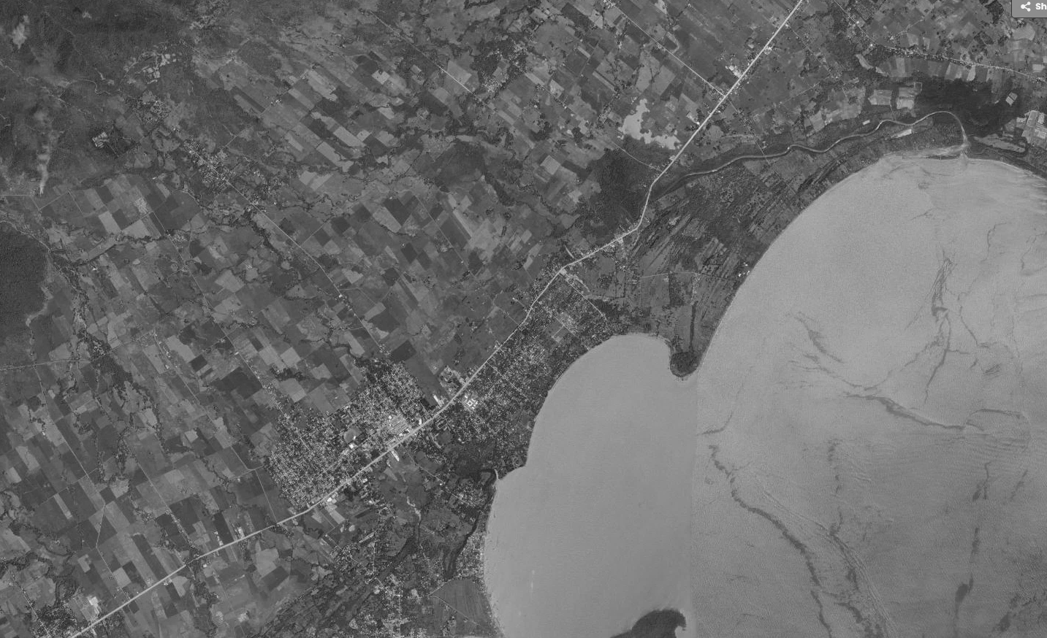
Brgy. Elvita
Flood-Prone area
Narra
Figure 3.2 shows the location situated near the flood-prone area of Brgy. Elvita, Narra, Palawan.

System Architecture
FLAIRE followed an offline-first, edge-based system architecture designed to operate in Brgy. Elvita, Narra, Palawan, even during internet or power interruptions. The architecture consists of four major layers: the sensor layer, communication layer, edge-processing layer, and user-interface and alert-dissemination layer.
Sensor Layer
The sensor layer consisted of an Adafruit 32u4 RFM9x LoRa hydrological sensor node deployed along the selected river section. The node was equipped with an ultrasonic water-level sensor and a rain gauge. The ultrasonic sensor measures river water level, while the rain gauge measured rainfall amount. The sensor node periodically collects hydrological measurements and transmits them to the Raspberry Pi 5 edge device through LoRa communication.
Communication Layer
The communication layer used LoRa as the primary transmission technology between the sensor node and the edge device. LoRa is suitable for the deployment area because it supports low-power, long-range wireless communication without requiring internet connectivity. Sensor readings were transmitted at a defined interval and stored locally upon receipt by the edge device.
Edge-Processing Layer
The edge-processing layer was hosted on a Raspberry Pi 5. It contains the local SQLite database, cached weather and tide forecast data, hybrid AI models, and system services. Cached seven-day weather and tide forecast data from the OpenMeteo API was updated at least daily (every six hours) whenever internet connectivity is available and stored locally for offline use.
The hybrid AI pipeline operated in two stages. First, the Random Forest model estimates flood propensity using historical and forecast meteorological and tide-related features: R1, R3, R7, rain_days, TMAX, TMIN, TideMax, and TideMin. Second, the fuzzy-logic classifier, composed of 20 rules (a 15-rule core plus 5 gap-fill rules), integrates the Random Forest output with the real-time water-level reading, its rate of rise, the cached forecast rainfall, and the tide level. The fuzzy-logic layer applied interpretable decision rules to classify the prevailing condition into one of four flood-risk levels: Receding, Alert, Alarm, or Critical.
Table 3.1
Fuzzy-logic decision rules (15-rule core plus 5 gap-fill rules)
Rule | Water level | Rate of rise | Forecast rain | Tide level | RF propensity | Risk class
1 | Low | Negative | None / Light | Low / Mid | Low | Receding
2 | Low | Near-Zero | None / Light | Low / Mid | Low | Receding
3 | Low / Medium | Near-Zero | Light | Low / Mid | Low | Receding
4 | Low / Medium | Moderate | Light / Moderate | Low / Mid | Low | Alert
5 | Medium | Moderate | Moderate | Mid | Low | Alert
6 | Medium | Moderate | Moderate / Heavy | Mid / High | Medium | Alarm
7 | Medium / High | Rapid | Moderate / Heavy | Mid / High | Medium | Alarm
8 | High | Rapid | Heavy | High / Extreme | High | Critical
9 | High | Near-Zero | None / Light | Mid | Low | Alert
10 | High | Near-Zero | Moderate / Heavy | Mid / High | Medium | Alarm
11 | Very High | Any | Any | Any | Any | Critical
12 | Low / Medium | Negative | Moderate / Heavy | Mid / High | High | Alert
13 | Medium | Negative | Heavy | High | High | Alarm
14 | Medium / High | Moderate | Moderate | High | High | Alarm
15 | High | Moderate | Moderate / Heavy | High | High | Critical
16 | High | Negative | Any | Any | High | Alarm
17 | High | Negative | Any | Any | Low / Medium | Alert
18 | High | Moderate | Any | Low / Mid | Low | Alert
19 | High | Moderate | Any | Low / Mid | Medium | Alarm
20 | High | Moderate | Any | Low / Mid | High | Alarm
All data, including sensor readings, cached forecasts, model outputs, alerts, and system logs, was stored in a local SQLite database. This allows FLAIRE to continue monitoring, classification, and dashboard operation without dependence on cloud services.
User-Interface and Alert-Dissemination Layer
The user-interface layer is a LAN-accessible web dashboard hosted on the Raspberry Pi 5. BDRRMC personnel use the dashboard to monitor real-time water-level and rainfall readings, cached forecast information, AI-based flood-risk classifications, historical trends, and system status. The dashboard remains accessible through the local network even when internet connectivity is unavailable.
The alert-dissemination layer sends SMS notifications to key barangay officials. When the system generates an Alarm or Critical classification, it automatically sends the corresponding SMS notification to the pre-configured BDRRMC contact numbers and records it in the local database. Upon receiving the alert, the BDRRMC decides whether to warn residents and carries out the corresponding action, including siren activation and social-media posting.

Entity Relationship Diagram
The Entity Relationship Diagram provides a visual map of the data structures, entities, and relationships within the FLAIRE system.

Figure 3.3
Entity Relationship Diagram of FLAIRE
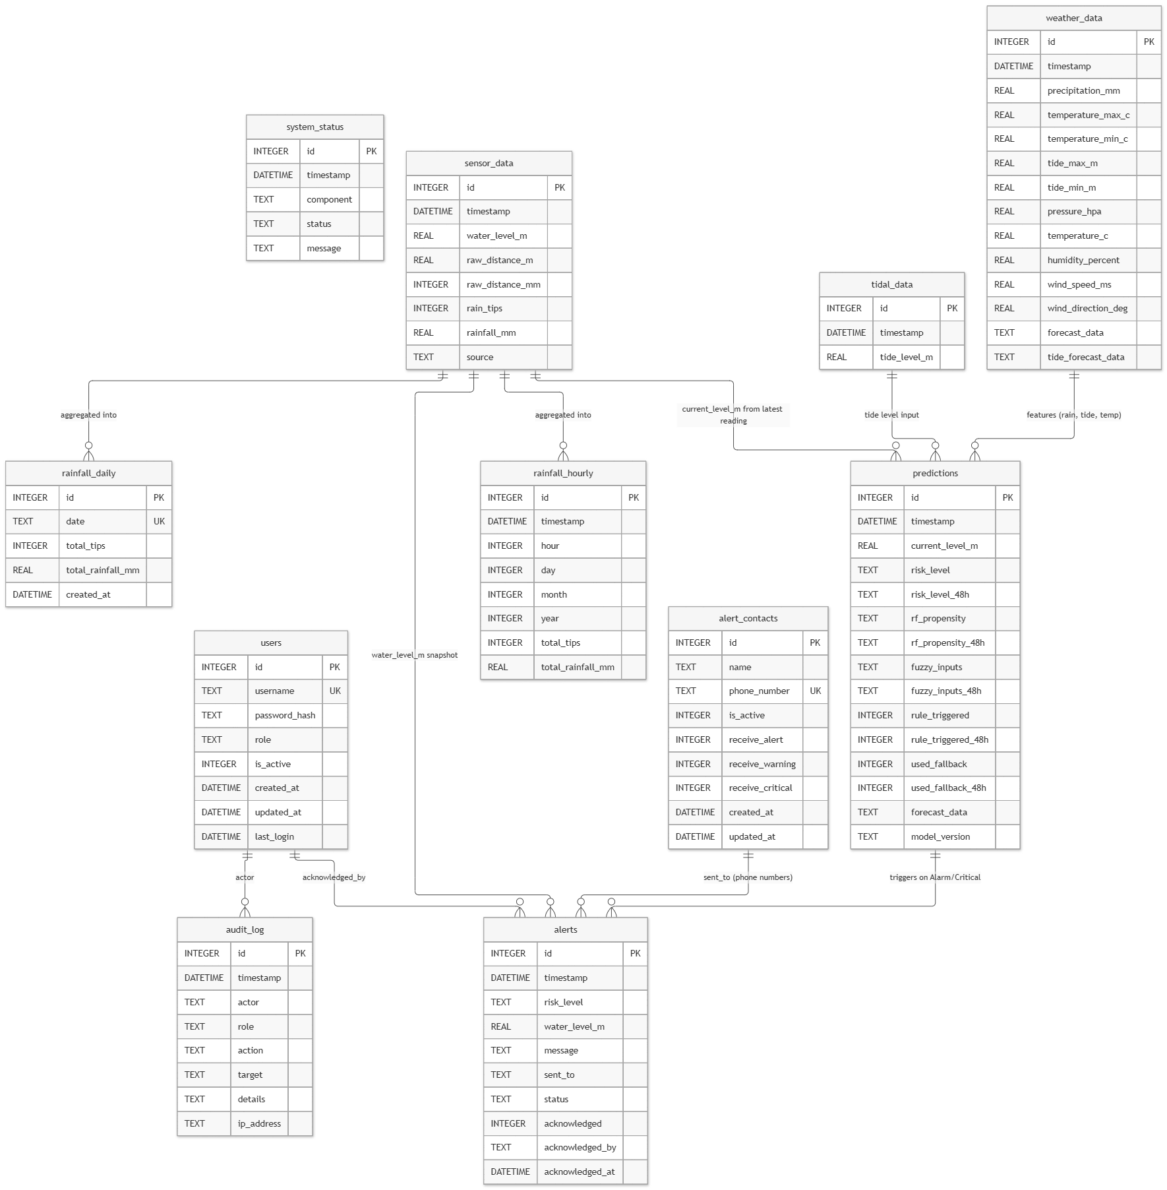
The ERD models the data layer of the River Monitor system, a SQLite database on a Raspberry Pi 5. It contains 11 entities grouped into six functional domains, sensor ingestion, weather/tide, AI prediction output, alerting, authentication/audit, and operations. Each entity is identified by a surrogate integer primary key (`id`), and natural keys such as `username`, `phone_number`, and `date` are enforced as `UNIQUE`. There are no declared foreign keys; integrity is maintained in application code, which keeps the schema simple and migration-friendly on SQLite.

Flowchart of the Developed System
The flowchart outlines the step-by-step process involved in the device operation, ensuring a clear and logical sequence of activities.

Figure 3.3.1
LoRa-enabled Hydrological sensor node flowchart
Start
Collect
Sensor Data
Transmit to
Edge Device via LoRa
End
Turn off device?
Yes
No
Figure 3.3.1 illustrates the operational workflow of the LoRa-enabled hydrological sensor node. The primary function of this node is to collect data on the river’s water level and rainfall amount, and transmits it to the edge device for processing every 5 seconds.
Figure 3.3.2
Edge device flowchart
Start
Collect Weather Forecast Data via API
Is Sensor Data available?
Wait for Data transmission
Data Processing:
- Cleaning
- Synchronization
Store Data to
Database
A
No
Yes
B
End
Parallel Risk Assessments
Fuzzy Logic
Risk Assessment
A
Random Forest Profensity
Log results
Turn off device
B
Yes
No
Update Dashboard
Figure 3.3.2 provides a visual representation of the Edge Device’s operational workflow. The Edge Device collects cached weather forecasts and real-time water-level readings, then processes these inputs using threshold logic and a Random Forest + fuzzy-logic flood risk classification system to determine flood-risk level.

Figure 3.3.3
LAN Dashboard
Start
Real-time Data
End
Close?
Yes
No
Show Dashboard
Access Edge Device via WEB BROWSER
(192.168.5.50)
Display Data Graphs
Display Risk
Risk Assessment
History
Display Logs
Alert Trigger
Send SMS
Log action
Figure 3.3.3 shows the workflow for the LAN-accessible dashboard available to BDRRMC officials. It serves as an offline-capable access point for viewing real-time data, edge-analyzed risk assessments, and logs. The dashboard also offers the option to trigger alerts, which are managed by BDRRMC officials.

Data Collection and Preprocessing
Data collection for this study involved historical, forecast, real-time, and field-observation data. These data supported the development, validation, and field evaluation of FLAIRE, an offline-first hybrid Random Forest and fuzzy-logic riverine flood-risk classification and early-warning system.
Historical meteorological data were obtained from PAGASA and historical tide data from NAMRIA; these sources provided the daily records used to train the Random Forest model. Forecast weather and tide data, by contrast, were retrieved from the Open-Meteo API. The dataset included the following variables used as inputs to the Random Forest flood-propensity model:
- R1 — rainfall amount for the previous one day
- R3 — rainfall amount for the previous three days
- R7 — rainfall amount for the previous seven days
- rain_days — number of rainy days within the relevant period
- TMAX — maximum temperature
- TMIN — minimum temperature
- TideMax — maximum tide level
- TideMin — minimum tide level
Cached seven-day weather and tide forecast data were also retrieved from the OpenMeteo API and updated whenever internet connectivity was available. These forecasts were stored in the local SQLite database hosted on the Raspberry Pi 5 edge device, allowing the system to use recent forecast information during internet outages.
Real-time hydrological data were collected using a LoRa-based sensor node equipped with an ultrasonic water-level sensor and a rain gauge. The sensor node measured river water level and rainfall amount, then transmitted the readings through LoRa to the Raspberry Pi 5 edge device. Upon receipt, the edge device validated the incoming data and stored them in the local SQLite database.
The sensor readings provided continuous, time-stamped observations of the river’s hydrological condition. These readings were used for dashboard monitoring, fuzzy-logic risk classification, and evaluation of the system’s ability to detect changes in water level and rainfall conditions.
Although a provincial Flood Early Warning System was previously installed in Brgy. Elvita, it was not operational, standardized, or formally documented during the study; therefore, the study did not treat a local threshold-based method as an established ground-truth baseline. Instead, the observed flood-risk condition during the field test was established using a combination of manual water-level readings, visual observations of the river, recorded weather conditions, and available information from the Municipal Disaster Risk Reduction and Management Office (MDRRMC).
During the field test, the researchers documented the actual hydrological condition at each observation period. This included manual water-level measurements, visual assessment of rising or receding water, rainfall condition, and any alerts or advisories received from the MDRRMC. These records served as the reference conditions against which the FLAIRE risk classifications were evaluated.
The existing community practice, visual water-level observation and reliance on MDRRMC alerts, was documented as part of the current flood-warning context. It was used to describe the limitations of the existing monitoring practice and to assess the potential value of FLAIRE’s continuous, offline, sensor-based monitoring and decision-support features.
Data preprocessing was performed to ensure that the collected datasets were complete, consistent, and suitable for model development, dashboard operation, and field-test evaluation. The following procedures were applied:
- Data cleaning. Duplicate records, invalid timestamps, impossible values, and erroneous sensor readings were identified and corrected or removed.
- Missing-value handling. Missing sensor readings or forecast values were handled using appropriate methods, such as interpolation, forward filling, or exclusion, depending on the extent and pattern of the missing data.
- Timestamp alignment. Sensor readings, cached weather and tide forecasts, manual observations, and system-generated risk classifications were synchronized based on their corresponding dates and times.
- Unit standardization. Water-level measurements were standardized in meters, while rainfall measurements were standardized in millimeters. Temperature and tide values were also converted into consistent units where necessary.
- Feature engineering. Derived variables were computed from the raw data, including rolling rainfall totals, number of rainy days, water-level rate of rise, and recent changes in water level.
- Input preparation for Random Forest. The historical and forecast variables R1, R3, R7, rain_days, TMAX, TMIN, TideMax, and TideMin were prepared for flood-propensity estimation.
- Input preparation for fuzzy logic. The Random Forest flood-propensity output, real-time water level, its rate of rise, cached forecast rainfall, and tide level were prepared as inputs to the 20-rule fuzzy-logic classifier.
- Dataset partitioning. Where sufficient historical data were available, the dataset was divided into training and testing subsets or evaluated using cross-validation to assess the Random Forest model’s performance.
All collected and processed data were stored in a local SQLite database hosted on the Raspberry Pi 5. The database contained sensor readings, cached weather and tide forecasts, Random Forest inputs and outputs, fuzzy-logic risk classifications, field observations, alerts, and system logs. Local storage allowed FLAIRE to operate independently of cloud services and preserved the data needed for dashboard visualization, model evaluation, and future refinement.

Target Respondents
The respondents of this study were selected using purposive sampling based on their direct involvement in disaster risk reduction, flood monitoring, and barangay-level decision-making in Brgy. Elvita, Narra, Palawan. Purposive sampling was appropriate because the study required respondents who were knowledgeable about the barangay’s flood conditions, existing warning practices, and operational needs for an offline-first flood early-warning system.
The BDRRMC focal persons evaluated FLAIRE in terms of its functionality, usability, reliability, perceived contribution to disaster preparedness, attitude toward use, and intention to use. Their feedback also provided context regarding the barangay’s current flood-monitoring practice, which primarily relies on visual observation of river water levels and alerts or advisories received from the Municipal Disaster Risk Reduction and Management Office (MDRRMC).
Because the acceptability evaluation involved BDRRMC focal persons, the findings should be interpreted as preliminary feedback from key local disaster-risk personnel rather than as a generalizable measure of system acceptability for the entire barangay. Nonetheless, their direct involvement in BDRRMC-related functions makes their insights relevant for assessing the practical usefulness, usability, and potential adoption of FLAIRE in the local deployment context.

Instrumentation
The study used hardware, field-data collection instruments, and a user-feedback instrument to evaluate the development and pilot deployment of FLAIRE. These instruments were used to collect hydrological data, document observed river conditions, record system outputs, and gather feedback from the BDRRMC focal persons regarding the acceptability and usefulness of the system.
The hardware instrumentation consisted of a LoRa-based hydrological sensor node and a Raspberry Pi 5 edge device. The sensor node was equipped with an Adafruit 32u4 RFM9x LoRa microcontroller, an ultrasonic water-level sensor, and a rain gauge. The ultrasonic sensor measured river water level, while the rain gauge measured rainfall amount. The sensor node transmitted its readings to the Raspberry Pi 5 edge device through LoRa communication.
The Raspberry Pi 5 served as the local edge device. It received sensor transmissions, stored data in a local SQLite database, processed cached OpenMeteo weather and tide forecast data, executed the Random Forest and fuzzy-logic classification pipeline, hosted the LAN-based web dashboard, and managed SMS notifications.
User acceptability was assessed using a structured survey questionnaire based on the Technology Acceptance Model (TAM). The instrument measured the respondents’ perceptions of FLAIRE in terms of:
- Functionality
- Usability
- Reliability
- Perceived contribution to disaster preparedness
- Attitude toward use
- Intention to use
The questionnaire used a five-point Likert scale, where 1 represented Strongly Disagree and 5 represented Strongly Agree. It was administered to the BDRRMC focal persons of Brgy. Elvita.
The survey instrument was reviewed and validated by subject-matter experts to ensure that the items were clear, relevant, and aligned with the study objectives. It was also pilot-tested before formal administration to identify unclear wording, technical terms, or response-format issues.

Gantt Chart
This section outlines the device's development timeline, covering phases from planning to finalization. It details each stage, ensuring timely completion and smooth progression, contributing to the successful development and efficient execution of the project.

Figure 3.4
Duration of the development of the system
 | Jan | Feb | Mar | Apr | May | Jun | Jul | Aug | Sep | Oct
Planning & Research
  Feb | Mar | Apr | May | Jun | Jul | Aug | Sep | Oct | Nov | Dec
  Feb | Mar | Apr | May | Jun | Jul | Aug | Sep | Oct | Nov | Dec
Design
Development
Test
Finalizing

Legend:
Duration

Start Task

End Task
The planning phase started in January and continued until March, followed by the development phase, which spanned from early April through May. Each task was marked by solid bars, with arrows indicating the start and end points. This structured timeline helps visualize the project`s progress, highlight dependencies, and ensure that each phase transitions smoothly into the next, ultimately aiding in effective project management

Cost and Benefits Analysis
This section outlines the costs for implementation and discusses benefits to the barangay and stakeholders. The budget prioritizes local edge computing and renewable power suitable for rural deployment.
Table 3.2
Material and Cost of System
Material | Cost
Node
Adafruit RFM95 LoRa | ₱ 2,500
Mini magnets | ₱ 100
Meshtastic 915 MHz LoRa antenna | ₱ 300
Reed switch | ₱ 200
MCP73871 power boost | ₱ 300
UART 7.5 m waterproof ultrasonic sensor | ₱ 1,500
3.5 W solar panel | ₱ 200
3.7 V 10 Ah battery | ₱ 220
Enclosure box | ₱ 250
PVC pipe | ₱ 1,000
Housing materials | ₱ 500
Subtotal - Node | ₱7,070
Edge
Meshtastic 915 MHz LoRa antenna | ₱ 300
52Pi RPi5 power expansion board | ₱ 1,600
Micro SD card | ₱ 750
RPi5 active cooler | ₱ 250
Raspberry Pi 5 2 GB board | ₱ 6,500
12 V 12 Ah LiFePO4 battery pack | ₱ 2,220
LoRa RFM95W transceiver board | ₱ 2,000
60 W solar panel with controller | ₱ 1,900
SIMCOM A7608e-H | ₱ 1,530
SMS load (yearly) | ₱ 2,000
Subtotal - Edge | ₱19,050
General
Breadboard (2 × 100) | ₱ 200
Wires | ₱ 200
Marine plywood | ₱ 400
Miscellaneous electrical components | ₱ 1,000
Subtotal - General | ₱1,800
Total | ₱27,920

Table 3.2 details materials for FLAIRE's offline-first deployment. Adafruit 32u4 RFM9x LoRa boards serve as the sensor node transmitting water level and rainfall amount via LoRa to the Raspberry Pi 5 edge device, which hosts the local SQLite database, Machine Learning model, and FastAPI LAN dashboard. Solar panel kits provide renewable charging during typhoon season power outages. Cached weather data and GSM modem (SMS delivery) eliminate cloud dependency. The weather-resistant enclosures protect against Palawan monsoon conditions.

Benefits Analysis:
FLAIRE is expected to provide technical, operational, and community-level benefits. Technically, the system provides continuous water-level and rainfall monitoring without requiring constant internet connectivity. It stores data locally, runs the Random Forest and fuzzy-logic classification pipeline on a Raspberry Pi 5, and displays information through a LAN-based dashboard.
Operationally, the system can support BDRRMC personnel by providing continuous hydrological information and AI-based risk classifications. Even under stable conditions, the system can provide a Receding classification and dashboard-based monitoring. During rising water or heavy rainfall, the system is designed to generate Alert, Alarm, or Critical classifications and to send SMS notifications for Alarm or Critical conditions.
At the community level, FLAIRE may improve situational awareness and support earlier preparedness by reducing dependence solely on visual water-level observation and external MDRRMC alerts. Because final alert dissemination remains under BDRRMC authority, the system functions as a decision-support tool rather than an autonomous warning system.

System Maintenance Plan
Maintenance procedures are planned to support the reliability and continuous operation of FLAIRE in Brgy. Elvita. Routine monitoring can be conducted through the edge device dashboard to track sensor uptime, database status, and model performance. Periodic on-site inspections should be performed every three months to verify enclosure integrity, clean solar panels, test GSM connectivity, and recalibrate ultrasonic sensors.
Corrective maintenance will address hardware failures, physical damage, and software issues through component replacement, system resets, and database recovery when necessary. Adaptive maintenance will include periodic retraining of the Machine Learning classification model using newly collected data and updates to system parameters based on observed conditions and stakeholder feedback.
Data security and backup measures will include automated local database backups, offsite storage, and role-based access control within the LAN environment. Maintenance responsibilities will be shared between designated barangay personnel and system developers to ensure sustainability of the deployed system.

Developer and Client Communication
A structured communication plan is planned to support coordination between the researcher, Brgy. Elvita officials, and BDRRMC personnel throughout the development and deployment of FLAIRE. This includes regular coordination meetings, progress updates, and shared documentation to facilitate requirements validation, system deployment, and user training.
Issue reporting and resolution will follow a structured process, where concerns are documented, classified by severity, and addressed through appropriate technical actions. Relevant documentation, including user manuals, troubleshooting guides, and system architecture references, will be provided to support system use and sustainability.
Chapter 4

RESULTS AND DISCUSSION
This chapter presents the results of the development and initial evaluation of FLAIRE, an offline-first AI-enhanced flood early-warning system for Brgy. Elvita, Narra, Palawan.
The evaluation used multiple forms of evidence: a held-out test set derived from historical meteorological and tidal data, a limited field deployment in Brgy. Elvita, a functional sweep of the fuzzy-logic input space, a preliminary check against four documented flood events, and a TAM-based acceptability survey. Because the field deployment encountered sensor-quality issues, uncertain rainfall verification, and battery depletion, its results are presented as preliminary operational findings rather than as validation of flood-warning performance during an actual flood event.

Current Flood Warning Practices in Brgy. Elvita
The BDRRMC focal persons reported that current flood monitoring in Brgy. Elvita relies primarily on a manual rain gauge, visual observation of the river, and a tide calendar. Flood-related advisories are received from the Municipal Disaster Risk Reduction and Management Office (MDRRMO), which issues alerts for the municipality as a whole.
The focal persons identified the municipality-wide scope of MDRRMO alerts as a major limitation. An alert may indicate flooding in parts of Narra, but it does not necessarily mean that Brgy. Elvita is affected. This creates uncertainty for barangay officials when interpreting whether an advisory requires local preparedness or response action.
The current process also depends on manual observation and external advisories. The focal persons stated that network or power interruptions can limit communication and affect warning and response efforts.

Table 4.1
Current flood warning practices, limitations, and data sources
Aspect | Findings from BDRRMC focal persons
Current monitoring practices | Manual rain gauge, visual river observation, and tide calendar
External warning source | MDRRMO alerts for the entire municipality
Main limitation | Municipal alerts may not apply to all barangays, including Brgy. Elvita
Communication constraint | Network or power outages limit communication
Available data sources | Manual rain gauge, visual river observation, and tide calendar
Identified need | Automated logs and faster localized alerts
Potential system response | Offline AI system with a local dashboard

The findings indicate that Brgy. Elvita currently relies on a combination of manual observation, tide information, and municipality-level advisories. While these practices provide some basis for flood awareness, they do not provide continuous, automated, barangay-specific water-level and rainfall records.
The focal persons stated that an offline AI system with a local dashboard could address these gaps through automated logs and faster localized alerts. FLAIRE was therefore designed to supplement existing practices by providing LoRa-based sensor monitoring, local data storage, cached forecast information, and a LAN-accessible dashboard. The system is intended to support, not replace, the BDRRMC’s use of MDRRMO advisories, manual observation, and tide information.
The limited field deployment did not establish that FLAIRE reduces warning delays or improves lead time during an actual flood. However, the focal persons’ responses establish a clear local need for automated, localized monitoring and decision-support information.

Development and Implementation of FLAIRE
FLAIRE was developed as an offline-first flood early-warning system consisting of cached weather and tide forecast data, a LoRa-based sensor node, a Random Forest flood-propensity model, a fuzzy-logic risk classification component, a local SQLite database, a LAN dashboard, and SMS alert functionality.
The system uses cached weather and tide forecast information obtained when internet connectivity is available. These data are stored locally so that the edge device can continue processing information during periods of limited connectivity.
The cached data support the Random Forest model’s use of rainfall, temperature, and tide-related features. They also provide contextual information that can be displayed through the LAN dashboard.
The system uses a LoRa-based sensor node to transmit water-level and rainfall readings to the local edge device. The uploaded deployment dataset contained 13,568 records, including timestamps, water-level readings, raw ultrasonic distance values, rain-tip counts, rainfall values, and a LoRa source identifier.
The dataset had a median interval of approximately 5.06 seconds between stored records and a maximum observed gap of approximately 175.49 seconds. The recorded timestamp span was approximately 21 hours and 31 minutes, from October 11, 2026 at 9:46:46 PM to October 12, 2026 at 7:17:29 PM.
The Random Forest model estimates a Low, Medium, or High flood-propensity category using daily meteorological and tidal features. These features include one-day, three-day, and seven-day rainfall; number of rainy days; maximum and minimum temperature; and maximum and minimum tide levels.
The model does not directly output Receding, Alert, Alarm, or Critical. Those four risk levels are produced by the fuzzy-logic classification component after combining the Random Forest output with water-level and rainfall information.
The fuzzy-logic component combines the Random Forest flood-propensity output with water-level and rainfall inputs to generate one of four risk levels: Receding, Alert, Alarm, or Critical. This component translates model output and local sensor conditions into a more operationally interpretable classification for the BDRRMC.
The field deployment did not provide sufficient confirmed rainfall or rising-water evidence to validate the fuzzy-logic component’s performance for Alert, Alarm, or Critical conditions. Therefore, no field-based accuracy, false-alarm rate, or lead-time result is reported for these categories.
The system stores sensor readings, cached forecast data, model outputs, and system logs in a local SQLite database. The LAN dashboard allows BDRRMC personnel to view current sensor status, water-level graphs, forecast-based water-level trends, Random Forest results, fuzzy-logic results, and alert history without requiring internet access.
The system also supports SMS alerts through a GSM modem; each alert is logged locally and sent when the modem is reachable. The BDRRMC retains authority over the final release of alerts, preserving human oversight in the warning process.

Random Forest Model Evaluation Results
The Random Forest model was trained using daily meteorological and tidal data from January 2, 2020 to December 31, 2024, obtained from PAGASA (meteorological) and NAMRIA (tidal). The dataset contained 1,826 daily records and was divided using a random stratified 80/20 train-test split, producing 1,460 training records and 366 test records.
The reported classification metrics were obtained from predictions on the held-out test set. No cross-validation was used, and the metrics were not computed from predictions on the training data.
The target variable consisted of three flood-propensity categories: Low, Medium, and High. These labels were generated through a rule-based composite scoring procedure using the same eight features used by the Random Forest model.
A composite score incorporated one-day, three-day, and seven-day rainfall; number of rainy days; maximum and minimum temperature; and maximum and minimum tide levels. Scores of at least 6.0 were labeled High, scores of at least 3.0 were labeled Medium, and scores below 3.0 were labeled Low.
Because the labels were derived from the same input features used by the model, the Random Forest results represent the model’s ability to approximate the predefined rule-based scoring scheme. They do not represent validation against independently documented flood events, observed water-level exceedances, or actual flood impacts.

Table 4.2
Random Forest performance on the held-out test set
Flood-propensity class | Precision | Recall | F1-score | Specificity | Test samples
Low | 0.9728 | 0.9728 | 0.9728 | 0.9725 | 184
Medium | 0.9298 | 0.8908 | 0.9099 | 0.9676 | 119
High | 0.8824 | 0.9524 | 0.9160 | 0.9736 | 63
Macro average | 0.9283 | 0.9387 | 0.9329 | — | 366
Weighted average | 0.9433 | 0.9426 | 0.9426 | — | 366

The Random Forest model obtained an overall test accuracy of 94.26%, correctly classifying 345 of 366 held-out samples. The Low category obtained the strongest performance, with precision, recall, and F1-score each equal to 0.9728.
The High category obtained a recall of 0.9524, correctly identifying 60 of 63 High-labeled samples. However, its precision was 0.8824 because eight Medium-labeled samples were classified as High. No High-labeled samples were classified as Low.
The results indicate that the Random Forest was able to reproduce the rule-derived Low, Medium, and High flood-propensity categories with high agreement on the held-out test set. The model obtained particularly strong performance for the Low category and high recall for the High category.
However, the reported performance should not be interpreted as predictive validation against actual flooding. Because the target labels were generated from the same features used by the model, the Random Forest was essentially learning to approximate the predefined scoring rule.
The evaluation also used a random stratified split rather than a chronological split. Because the dataset contains rolling rainfall features and daily meteorological and tidal observations, adjacent days may appear in both the training and test sets. This may inflate apparent generalization performance.
Therefore, the Random Forest results demonstrate consistency with the predefined flood-propensity scoring rule on a held-out test set. They do not establish forecast lead time, actual flood-prediction accuracy, or superiority over a traditional threshold-based warning method.

Fuzzy-Logic Coverage and Functional Verification
Because the limited field deployment produced only low-water (Receding) conditions, the fuzzy-logic classifier was also verified by exercising it across its full input space rather than only on field data. Its five inputs are water level (0-3000 mm), rate of rise (-100 to 100 mm/h), forecast rainfall (0-100 mm/day), tide level (0-5 m), and Random Forest flood propensity (Low, Medium, High). The classifier was swept using the peak value of each membership function, giving 4 x 4 x 4 x 4 x 3 = 768 dominant-term combinations, and also on a coarser 3,150-point grid spanning the full input ranges.
All 768 dominant-term combinations and all 3,150 grid points returned a defined risk class, with no exceptions or runtime errors, and all four risk classes were reachable. Table 4.3 lists a representative input and output for each class. The output was monotonic in water level and in rate of rise, with no violations. Forecast rainfall, tide level, and Random Forest propensity each produced a single small non-monotonic step; inspection shows that these occur where the output transitions between an explicit rule and the membership-weighted fallback, and are boundary effects of the hybrid design rather than contradictory behavior.
Of the 768 dominant-term combinations, 296 (38.5%) were resolved by an explicitly identified rule and the remainder by the membership-weighted fallback, which guarantees a defined output whenever no rule fires. This confirms that the classifier is functionally complete and behaves sensibly across its whole operating range, including the Alert, Alarm, and Critical regimes that the field deployment could not observe. It is a functional verification of the fuzzy layer, not evidence of accuracy against actual floods.
Table 4.3
Representative fuzzy-logic inputs and outputs for each risk class
Risk class | Water level (mm) | Rate of rise (mm/h) | Forecast rain (mm/day) | Tide (m) | RF propensity | Crisp output
Receding | 300 | -2 | 2 | 0.3 | Low | 0.44
Alert | 800 | 2 | 10 | 0.5 | Low | 2.00
Alarm | 1000 | 2 | 25 | 1.0 | Medium | 4.00
Critical | 2000 | 12 | 50 | 2.0 | High | 5.67

Preliminary Check Against Documented Flood Events
As a preliminary, non-circular check, the four flood events documented for Brgy. Elvita between 2020 and 2025 were evaluated individually. The daily features for each date were passed through the trained Random Forest. Because four events cannot support a statistical estimate, the result is reported as a case check rather than as an accuracy or false-alarm measure.
Table 4.4
Random Forest output for the four documented flood events
Flood event | R1 (mm) | R3 (mm) | R7 (mm) | Rainy days | TideMax (m) | RF class | Rule-derived class
21/10/2021 | 0.2 | 17.4 | 35.0 | 5 | 2.56 | Medium | Medium
30/03/2022 | 76.9 | 142.6 | 142.6 | 3 | n.a. | High | High
27/12/2022 | 18.1 | 18.1 | 50.2 | 5 | 3.06 | High | High
23/11/2023 | 39.1 | 39.2 | 40.4 | 3 | 2.51 | Medium | Medium

Two of the four documented flood events were classified as High (30/03/2022 and 27/12/2022) and two as Medium (21/10/2021 and 23/11/2023). The model's output matched the rule-derived class for all four dates. The two High cases coincided with the strongest accumulated-rainfall signals in the set: the 30/03/2022 event recorded R1 = 76.9 mm and R3 = R7 = 142.6 mm, while the 27/12/2022 event recorded R7 = 50.2 mm together with a 3.06 m tide. The two Medium cases occurred under only moderate accumulated rainfall (R7 = 35.0 mm and 40.4 mm), below the range that the High class represents; the median R7 of High-class days is approximately 78 mm. Because the High class is defined mainly by accumulated rainfall, flood events that are not accompanied by heavy rainfall accumulation, such as tide- or water-level-driven flooding, are not represented by the present feature set.
One of the four dates (30/03/2022) also had a missing tide value in the historical dataset, a data-quality gap that should be corrected before further analysis. Taken together, these observations reinforce that the rule-derived labels reflect accumulated-rainfall conditions rather than flood occurrence as such, and that independent flood-event labels, together with tide- or water-level-aware features, are required to establish real predictive skill.

Limited Field Deployment Results
FLAIRE was deployed beside the bridge in Brgy. Elvita to observe its behavior under field conditions. The researchers reported an intended deployment period from October 12 at 11:00 AM to October 14 at 10:00 AM, or approximately 47 hours. However, the uploaded sensor dataset spans approximately 21 hours and 31 minutes based on its stored timestamps.
The recorded data begins on October 11 at 9:46 PM, approximately 13 hours before the reported installation time of October 12 at 11:00 AM, and ends approximately 21.5 hours later. This difference between the reported and recorded periods requires verification of the Raspberry Pi clock, timezone configuration, data-export process, or actual powered-operation period. The available dataset should not be extended or relabeled to match the intended deployment duration.
The uploaded dataset contained 13,568 LoRa-sourced records. The median water-level reading was 0.122 m, while the recorded water-level range was −0.012 m to 2.500 m. The dataset contained 67 records with a raw ultrasonic distance of zero and a corresponding water-level reading of 2.500 m. It also contained 124 records with negative calculated water-level values. In addition, five records contained implausibly short raw distances (four at 250 mm and one at 959 mm), producing water-level readings of 2.250 m and 1.541 m, respectively. These records were flagged for quality review rather than interpreted as actual river-level changes. Excluding these anomalous records, the water level remained between approximately 0.01 m and 0.18 m, which lies entirely within the lowest (Low) water-level band of the fuzzy-logic classifier (below 0.61 m) and well below the alert threshold (0.80 m); the deployment therefore could not exercise the Alert, Alarm, or Critical classes.
A dangling wire within the sensing area may have triggered anomalous 2.5 m readings. This observation is consistent with the presence of zero-distance records in the dataset, although the exact cause of every anomalous reading was not independently established.

Table 4.5
Preliminary sensor-data quality findings
Item | Result
Total records | 13,568
Recorded timestamp span | Approximately 21 hours and 31 minutes
Median interval between records | Approximately 5.06 seconds
Maximum interval between adjacent records | Approximately 175.49 seconds
Median water level | 0.122 m
Water-level range | −0.012 m to 2.500 m
Zero raw-distance records | 67
Negative calculated water-level records | 124
Impossibly short raw-distance records (250 mm, 959 mm) | 5
Positive rainfall-entry records | 671

Direct rainfall observation was limited because the researchers were not continuously present at the deployment site during the full monitoring period. Therefore, the occurrence and amount of rainfall during the deployment window could not be independently verified.
Although rainfall was not observed during installation, the sensor dataset contained 671 records with positive rainfall values, each recorded as 0.2 mm. These entries require verification against the rain-gauge configuration, logging behavior, and local weather conditions before they can be interpreted as actual precipitation. All 671 entries occurred within a single window from October 12 at 1:24 AM to 6:20 AM, and the rain-tip count never exceeded one per record, which is consistent with a repeated status or cumulative value rather than per-interval tipping-bucket increments.
Because rainfall occurrence was not independently verified and the rain-gauge readings require validation, the deployment does not provide sufficient evidence to evaluate the system’s performance under confirmed rainfall or rising-water conditions.
Data collection ended earlier than intended following battery depletion. The researchers identified the side-mounted solar panel as a possible contributor to insufficient charging; however, the relative contributions of panel placement, battery capacity, charging performance, and device power consumption were not quantified during deployment.
Therefore, the deployment demonstrated initial field operation of the sensor and data-logging workflow, but it did not demonstrate sustained autonomous operation for the intended deployment period
The available evidence supports the following limited operational findings:
- The sensor node transmitted water-level and rainfall-related data to the local system.
- The system recorded a substantial number of timestamped readings.
- The dashboard was designed to display live status, sensor status, water-level graphs, forecast-based trends, Random Forest results, fuzzy-logic results, and alert history.
- The deployment identified installation, sensor-quality, rainfall-verification, and power-supply issues requiring correction.
- The deployment did not establish validated performance for Receding, Alert, Alarm, or Critical classifications during an actual flood event.

Initial Acceptability Results
The two BDRRMC focal persons provided initial feedback on FLAIRE’s functionality, usability, perceived reliability, perceived contribution to disaster preparedness, attitude toward use, and intention to use. Their reported average ratings were favorable across all six dimensions.

Table 4.6
Initial acceptability ratings from BDRRMC focal persons
Dimension | Reported average rating
Functionality | 5.00
Usability | 4.75
Perceived reliability | 5.00
Perceived contribution to disaster preparedness | 5.00
Attitude toward use | 5.00
Intention to use | 5.00

The focal persons gave FLAIRE a reported average usability rating of 4.75, while the remaining five dimensions received reported averages of 5.00. These results represent the perceptions of the two participating BDRRMC focal persons and should not be generalized to all barangay officials or residents.
The perceived-reliability rating should be interpreted alongside the field-deployment findings. Although the focal persons perceived the system as reliable, the deployment identified battery depletion and anomalous sensor readings that require correction before the system can be considered operationally dependable during extended monitoring periods.
The results show that Brgy. Elvita currently relies on manual rain-gauge readings, visual river observation, a tide calendar, and MDRRMO alerts issued for the entire municipality. The focal persons identified the mismatch between municipality-wide alerts and barangay-specific conditions, limited continuous local monitoring, and communication constraints as key gaps.
FLAIRE was designed to address these gaps through continuous LoRa-based sensor monitoring, local data storage, cached forecast data, a LAN dashboard, and SMS alerts. The focal persons’ responses support the relevance of these features, particularly automated logs and faster localized alerts.
The Random Forest component obtained high agreement with its rule-derived Low, Medium, and High flood-propensity labels on a held-out test set. However, because the labels were generated from the same input features and the evaluation used a random rather than chronological split, the result does not establish independent flood-prediction performance or forecast lead time.
The limited field deployment provided initial evidence that the sensor and data-logging workflow could operate in the deployment environment. However, anomalous readings, unverified rainfall entries, battery depletion, and the shorter recorded-data span prevent any conclusion that FLAIRE reliably classified flood risk or provided effective warning lead time during actual flood conditions.
Chapter 5

SUMMARY OF FINDINGS, CONCLUSIONS, AND RECOMMENDATIONS
This chapter presents the summary of findings, conclusions, and recommendations based on the development and initial evaluation of FLAIRE, an offline-first AI-enhanced flood early-warning system for Brgy. Elvita, Narra, Palawan. The findings are based on the responses of two BDRRMC focal persons, the evaluation of the Random Forest flood-propensity model using a held-out test set, and the limited field deployment of the system.

Summary of Findings
The study found the following:
- Current flood warning practices. Current flood monitoring in Brgy. Elvita relies primarily on a manual rain gauge, visual observation of the river, and a tide calendar. Flood advisories are received from the MDRRMO and apply to the entire municipality rather than to individual barangays.
- Limitations of current practices. The BDRRMC focal persons identified the municipality-wide scope of MDRRMO alerts as a major limitation because an alert may not apply to all barangays, including Brgy. Elvita. They also identified network and power interruptions as factors that can limit communication during warning and response activities.
- Available data sources and identified needs. The available local data sources include a manual rain gauge, visual river observation, and a tide calendar. The focal persons stated that automated data logs and faster localized alerts could help address the limitations of the current process.
- System development. FLAIRE was designed and developed as an offline-first system that integrates cached weather and tide forecast data, a LoRa-based water-level and rainfall sensor node, a Random Forest flood-propensity model, a fuzzy-logic risk classification component, a local SQLite database, a LAN dashboard, and SMS alert functionality.
- Random Forest model evaluation. The Random Forest model obtained 94.26% accuracy on a held-out test set for classifying rule-derived Low, Medium, and High flood-propensity categories. The model obtained an F1-score of 0.9728 for the Low category, 0.9099 for the Medium category, and 0.9160 for the High category.
- Interpretation of model results. The Low, Medium, and High labels were generated through a rule-based composite scoring procedure using the same meteorological and tidal features used by the Random Forest model. Therefore, the reported performance reflects the model’s ability to approximate the predefined scoring rule, not validation against independently documented flood events.
- External check against documented events. When the four documented flood events for Brgy. Elvita (2020-2025) was evaluated individually, two were classified as High (30/03/2022 and 27/12/2022) and two as Medium (21/10/2021 and 23/11/2023). The two High cases coincided with the strongest accumulated-rainfall signals in the set (R3/R7 up to 142.6 mm, and R7 = 50.2 mm with a 3.06 m tide), while the two Medium cases occurred under only moderate accumulated rainfall (R7 = 35.0 mm and 40.4 mm), below the range represented by the High class. The model therefore identifies flood events accompanied by heavy accumulated rainfall but does not capture events without such a rainfall signal.
- Fuzzy-logic functional verification. Sweeping the fuzzy-logic classifier across its full input ranges (768 dominant-term combinations and 3,150 grid points) returned a defined class for every combination with no errors, all four risk classes were reachable, and the output was monotonic in water level and rate of rise, with single boundary steps in the other three inputs.
- Field deployment duration. The researchers reported an intended deployment period from October 12 at 11:00 AM to October 14 at 10:00 AM, or approximately 47 hours. However, the uploaded sensor dataset spans approximately 21 hours and 31 minutes based on its stored timestamps. The difference requires verification of the device clock, timezone configuration, data export process, or actual powered-operation period.
- Sensor data quality. The deployment dataset contained 13,568 LoRa-sourced records. It included 67 records with zero raw ultrasonic distance and a corresponding 2.500 m water-level reading, 124 records with negative calculated water-level values, and five records with implausibly short raw distances (250 mm and 959 mm) that produced water-level readings of 2.250 m and 1.541 m. These readings were flagged for quality review rather than interpreted as actual river-level changes.
- Rainfall verification. Rainfall was not observed during installation, but the researchers were not continuously present at the site during the deployment window. Therefore, rainfall occurrence and amount could not be independently verified. The dataset contained 671 positive rainfall entries, which require validation before they can be interpreted as actual precipitation.
- Power supply constraint. Data collection ended earlier than intended following battery depletion. The researchers identified the side-mounted solar panel as a possible contributor to insufficient charging, although the relative contributions of panel placement, battery capacity, charging performance, and device power consumption were not quantified.
- User acceptability. The two BDRRMC focal persons provided favorable initial feedback. Functionality, perceived reliability, perceived contribution to disaster preparedness, attitude toward use, and intention to use each received a reported average rating of 5.00, while usability received 4.75

Conclusions
Based on the findings, the following conclusions are drawn:
- Current practices are manual and municipality-wide. Flood monitoring in Brgy. Elvita depends largely on manual rain-gauge readings, visual river observation, a tide calendar, and MDRRMO advisories issued for the entire municipality. These practices do not provide continuous, automated, barangay-specific water-level and rainfall information.
- There is a need for localized monitoring. Because MDRRMO alerts cover the entire municipality, they may not accurately reflect flood conditions in Brgy. Elvita. This supports the need for a barangay-level monitoring and decision-support system.
- FLAIRE addresses the identified need through its design. FLAIRE was designed to supplement existing practices by providing LoRa-based sensor monitoring, local data storage, cached forecast information, a LAN dashboard, and SMS alerts. These features respond to the focal persons’ identified need for automated logs and faster localized alerts.
- The Random Forest model reproduced its rule-derived labels with high agreement. The model obtained 94.26% accuracy on a held-out test set. However, because the Low, Medium, and High labels were derived from the same input features, the result demonstrates consistency with the predefined scoring rule rather than independent flood-prediction performance.
- The model evaluation does not establish flood forecasting or lead time. The evaluation used a random stratified split rather than a chronological split, and no forecast lead time was measured. Therefore, the results do not establish that the model can predict flooding 24 to 48 hours in advance or outperform a traditional threshold-based warning method.
- The prototype captured documented flood events only partially. Of the four flood events documented for the barangay between 2020 and 2025, two were classified as High and two as Medium. The two High cases coincided with the strongest accumulated-rainfall signals in the set, while the two Medium cases occurred under only moderate accumulated rainfall. This, together with the rainfall-centred feature set and the label-derivation issue, indicates that the model identifies floods accompanied by heavy accumulated rainfall but cannot yet be shown to identify real flood events generally, and that tide- or water-level-aware features and independent labels are required.
- Whether machine-learning models can be used to assist in assessing flood risk is answered only partially by this study. The Random Forest layer was trained and executed on low-cost edge hardware and reproduced the predefined scoring rule with high agreement, which establishes the technical feasibility of including a machine-learning model in an offline-first barangay system. It does not establish predictive usefulness beyond the composite score itself, because the model learned from labels derived from the same eight features, and the two documented flood events it classified as High are precisely those with the strongest accumulated-rainfall signals, which the scoring rule already captures. Whether the AI layer adds value therefore remains to be demonstrated using independent flood-event labels, water-level and tide-aware features, and chronological validation.
- The field deployment demonstrated limited initial operation. The system recorded a substantial number of timestamped sensor readings, but the available dataset spans only approximately 21.5 hours. The deployment therefore did not demonstrate sustained autonomous operation for the intended deployment period.
- Sensor and power issues must be resolved. The anomalous zero-distance, negative, and implausibly-short-distance water-level readings, together with battery depletion, indicate that sensor mounting, cable management, invalid-reading handling, solar-panel placement, and power monitoring require improvement.
- Rainfall conditions remain uncertain. Because rainfall was not continuously observed and the rain-gauge entries require validation, the deployment cannot be used to evaluate the system’s performance under confirmed rainfall or rising-water conditions.
- Initial acceptability was favorable but limited. The two BDRRMC focal persons perceived FLAIRE as functional, usable, reliable, useful for disaster preparedness, and worth using. However, these results are preliminary and should not be generalized because only two focal persons participated

Recommendations
Based on the findings and conclusions, the following recommendations are offered:
For system improvement
- Improve sensor installation and cable management. Secure the ultrasonic sensor, wiring, and enclosure to prevent dangling wires or obstructions from producing false distance readings. Add physical inspection procedures during installation and maintenance.
- Implement invalid-reading handling. Configure the system to detect and flag zero-distance readings, negative water-level values, sudden unrealistic jumps, and other invalid measurements. Retain the raw values for audit purposes while preventing questionable readings from directly triggering alerts.
- Validate the rain gauge. Verify whether each positive rainfall entry represents one physical tipping-bucket event, a repeated status value, or another logging behavior. Conduct controlled tests by manually adding a known volume of water and comparing the recorded tips and rainfall values.
- Implement reliable SMS delivery. Add store-and-forward queuing with automatic retry so that alerts are delivered once cellular connectivity is restored, and record a delivery confirmation for each message. The current prototype sends an alert only when the GSM modem is reachable and does not confirm receipt.
- Improve power reliability. Reposition or enlarge the solar panel, verify battery capacity and charging performance, and add battery-voltage and charging-current monitoring. Conduct a controlled power test before another field deployment.
- Synchronize and document timestamps. Configure the Raspberry Pi to use a reliable time source, document its timezone, and record the actual installation, startup, shutdown, and retrieval times. Add a separate corrected timestamp field only if a documented clock offset is established.
For model improvement
- Use independent flood-event labels. Replace or supplement the rule-derived Low, Medium, and High labels with documented flood events, observed river-level exceedances, BDRRMC or MDRRMC records, or expert-validated flood-impact records. A preliminary check of the four documented flood events found that the model classified only the two events with the strongest accumulated-rainfall signals as High, assigning the same class that the scoring rule already produces, while the two events with moderate accumulated rainfall were classified as Medium. Because the High class is defined mainly by accumulated rainfall, the feature set should also be extended with a water-level or tide-condition feature before the model is re-evaluated on independent labels.
- Use chronological validation. Replace the random stratified split with a chronological date cutoff, such as training on 2020–2023 and testing on 2024, or use time-series cross-validation. This will provide a more realistic assessment of generalization for daily meteorological and tidal data.
- Evaluate forecast lead time. Structure future evaluation to measure how far in advance the system identifies rising-risk conditions before a documented flood event. Do not claim a 24–48-hour decision window unless this is empirically measured.
- Evaluate the fuzzy-logic classifier separately. Test the Receding, Alert, Alarm, and Critical outputs against documented flood conditions, observed water levels, and BDRRMC-validated warning thresholds.
- Compare FLAIRE with a defined threshold baseline. Use the same historical period and evaluation criteria to compare the complete FLAIRE workflow with a clearly defined threshold-based warning method. Report accuracy, precision, recall, F1-score, false-alarm rate, and lead time only after this comparison is completed.
For future deployment
- Conduct a longer and fully powered deployment. Repeat the deployment after correcting the power and sensor issues. Record the actual powered-operation period, transmission success rate, battery level, solar-charging performance, and any system errors.
- Use multiple sensor nodes with identifiers. Include a node ID in every transmitted record so that readings from different sensor locations can be distinguished and analyzed separately.
- Log complete system outputs. Store Random Forest propensity outputs, fuzzy-logic risk classifications, alert events, SMS delivery status, dashboard interactions, and system errors alongside the raw sensor data.
- Expand user evaluation. Include additional BDRRMC personnel, barangay officials, and selected community representatives in future acceptability testing. Use item-level responses and qualitative feedback to provide a more complete assessment.
- Retain human decision-making. Continue to require BDRRMC confirmation before releasing public alerts. FLAIRE should function as a decision-support tool that supplements MDRRMO advisories, manual observation, and local knowledge, rather than as an autonomous warning authority.
- Exercise and validate the higher risk classes. Repeat the field deployment until Alert, Alarm, and Critical conditions are actually observed, because the initial test recorded only low-water (Receding) conditions and therefore could not validate the higher risk classifications.

References
Ahmed, H. (2021). Low Power IoT Sensor System for Underground Drainage Monitoring. Tallinn University of Technology. Retrieved from https://digikogu.taltech.ee/et/Download/b456bb87-faa4-4b32-adc6-757bb5e79321
Bibi, H., Saleem, S., Jalil, Z., Nasir, M., & Alsubait, T. (2025). Riverine Flood Prediction and Early Warning in Mountainous Regions using Artificial Intelligence. arXiv, 18645. Retrieved from doi.org/10.48550/arXiv.2505.18645
Blessing, L. T., & Chakrabarti, A. (2009). DRM, a Design Research Methodology. Springer-Verlag London Limited. Retrieved from https://content.e-bookshelf.de/media/reading/L-8059-9cd0399cfa.pdf
Budimir, M., Trogrlić, R. Š., Almeida, C., Arestegui, M., Vásquez, O. C., Cisneros, A., . . . Ndiaye, A. (2025). Opportunities and challenges for people-centered multi-hazard early warning systems: Perspectives from the Global South. iScience, 112353. doi:10.1016/j.isci.2025.112353
Cacal, J. C., Austria, V. C., & Taboada, E. B. (2023). Extreme Event-based Rainfall-Runoff Simulation Utilizing GIS Techniques in Irawan Watershed, Palawan, Philippines. Civil Engineering Jounal, 220–232. Retrieved from https://doi.org/10.28991/CEJ-2023-09-01-017
Department of Science and Technology - Advanced Science and Technology Institute. (2024). 2024 DOST-ASTI Annual Report. DOST-ASTI. Retrieved from https://asti.dost.gov.ph/wp-content/uploads/2024-DOST-ASTI-Annual-Report.pdf
Gray, V. (2023). Mobile-based Early Warning Systems: For effective and inclusive alerting. Global Disaster Preparedness Center / IFRC. Retrieved from https://preparecenter.org/wp-content/uploads/2023/04/briefing_note_mobile-based-early-warning-systems.pdf
GSMA. (2022). Early Warning Systems in the Philippines: Building resilience through mobile and digital technologies. GSMA. Retrieved from https://www.gsma.com/solutions-and-impact/connectivity-for-good/mobile-for-development/wp-content/uploads/2022/06/PhilippinesEWS_R_Web.pdf
Jenkins, T. (2025, September 2). Case Study (Philippines): IoT and Mobile Tech for Anticipatory Action. Retrieved from People in Need Philippines: https://philippines.peopleinneed.net/en/case-study-philippines-iot-and-mobile-tech-for-anticipatory-action-12880gp
Kim, D., Park, J., Han, H., Lee, H., Kim, H. S., & Kim, S. (2023). Application of AI-Based Models for Flood Water Level Forecasting and Flood Risk Classification. KSCE Journal of Civil Engineering, Volume 27, Issue 7, Pages 3163-3174. Retrieved from linkinghub.elsevier.com/retrieve/pii/S1226798824040157
Macalalad, R. V., Xu, S., Badilla, R. A., Paat, S. F., Tajones, B. C., Chen, Y., & Bagtasa, G. (2021). Flash flood modeling in the data-poor basin: A case study in Matina River Basin. Tropical Cyclone Research and Review, 87-95. Retrieved from https://doi.org/10.1016/j.tcrr.2021.06.003
Mesias, C. G., & Bagtasa, G. (2025). AI-Based Tropical Cyclone Rainfall Forecasting in the Philippines Using Machine Learning. Meteorological Applications, Volume 32, Issue 4, e70083. Retrieved from https://doi.org/10.1002/met.70083
Miyamoto, M., Kakinuma, D., Ushiyama, T., Rasmy, A. W., Yasukawa, M., Bacaltos, D. G., . . . Kitsuregawa, M. (2022). Co-Design for Enhancing Flood Resilience in Davao City, Philippines. Water, 978. Retrieved from https://www.mdpi.com/2073-4441/14/6/978
National Disaster Risk Reduction and Management Council. (2020). National Disaster Risk Reduction and Management Plan 2020 - 2030: RESULTS-BASED MONITORING AND EVALUATION PLAN. NDRRMC. Retrieved from https://rbmes-api.ndrrmc.gov.ph/download/RBMES_NDRRMP_2020-2030.pdf
Radyo Natin Nationwide. (2020, October 28). Palawan installs 20 flood early warning devices. Retrieved from Radyo Natin Nationwide: https://www.radyonatin.com/post.php/2114.ea5155cc7ab189f9
Refadah, S. S. (2025). Development in flood forecasting: A comprehensive review of complex and machine learning models. Physics and Chemistry of the Earth, Parts A/B/C, Volume 139, 103975. Retrieved from https://doi.org/10.1016/j.pce.2025.103975
Schumacher, R. S., Hill, A. J., Nelson, J. A., Erickson, M. J., Trojniak, S. M., & Herman, G. R. (2021). From Random Forests to Flood Forecasts: A Research to Operations Success Story. Bulletin of the American Meteorological Society, Vol. 109, Issue 9, E1742–E1755. Retrieved from https://doi.org/10.1175/BAMS-D-20-0186.1
Sehgal, D. R., Gurudiwan, P., & Pant, S. (2025). Real-Time Flood Prediction Using Remote Sensing and Edge Computing. International Journal of Environmenal Sciences, 1459. Retrieved from https://doi.org/10.64252/7qha5q27
Semtech Corporation. (2024, March). LoRa® and LoRaWAN®. Semtech Corporation. Retrieved from Semtech Corporation: https://www.semtech.com/uploads/technology/LoRa/lora-and-lorawan.pdf
SERVANDO, N. T. (2023, November 21). KOICA and DOST-PAGASA Sign Agreement to Enhance Disaster Resilience. Retrieved from PAGASA: https://www.pagasa.dost.gov.ph/press-release/146

BIONOTES
UNDERGRADUATE RESEARCHER
Nathaniel S. Betita | Nathaniel S. Betita was born on December 26, 2000. He is a third-year student at Palawan State University Narra-Campus, where he is currently pursuing a Bachelor of Science in Computer Science. He resides in Barangay Panacan II, Narra, Palawan. With a keen interest in technology and innovation, he aspires to pursue a career as a game developer.


THESIS/DISSERTATION ADVISER
Joel P. Gulane Jr. M.I.T. | Joel P. Gulane Jr. is a dedicated educator and the current department head of the Computer Science program at Palawan State University Narra Campus.  His commitment to education is evident in his passion for teaching, training, and his involvement in the technology and computer-related industries.  His commitment to education is evident in his passion for teaching, training, and his involvement in the technology and computer-related industries.


Appendices

Appendix A
USER MANUAL

Appendix B
SOURCE CODE

Appendix C
SURVEY QUESTIONNAIRE

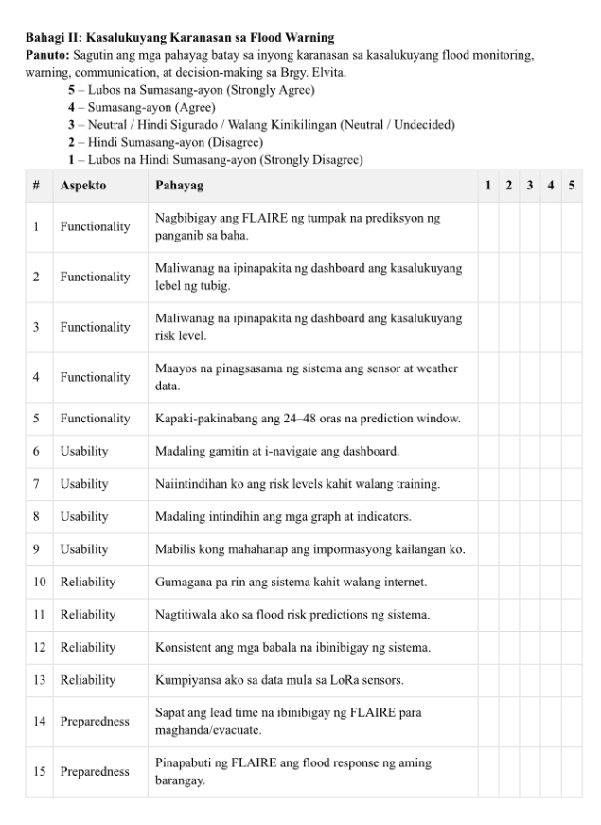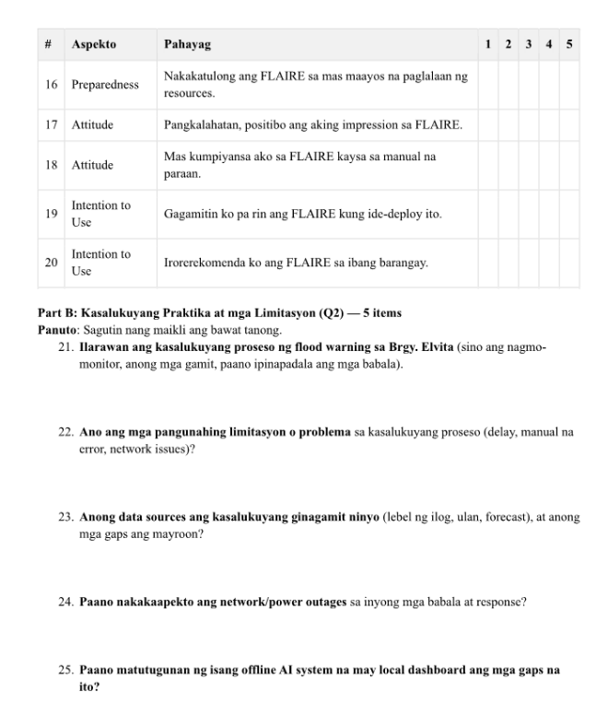

Appendix D
INTERVIEW, PROTOTYPE, DOCUMENTATION
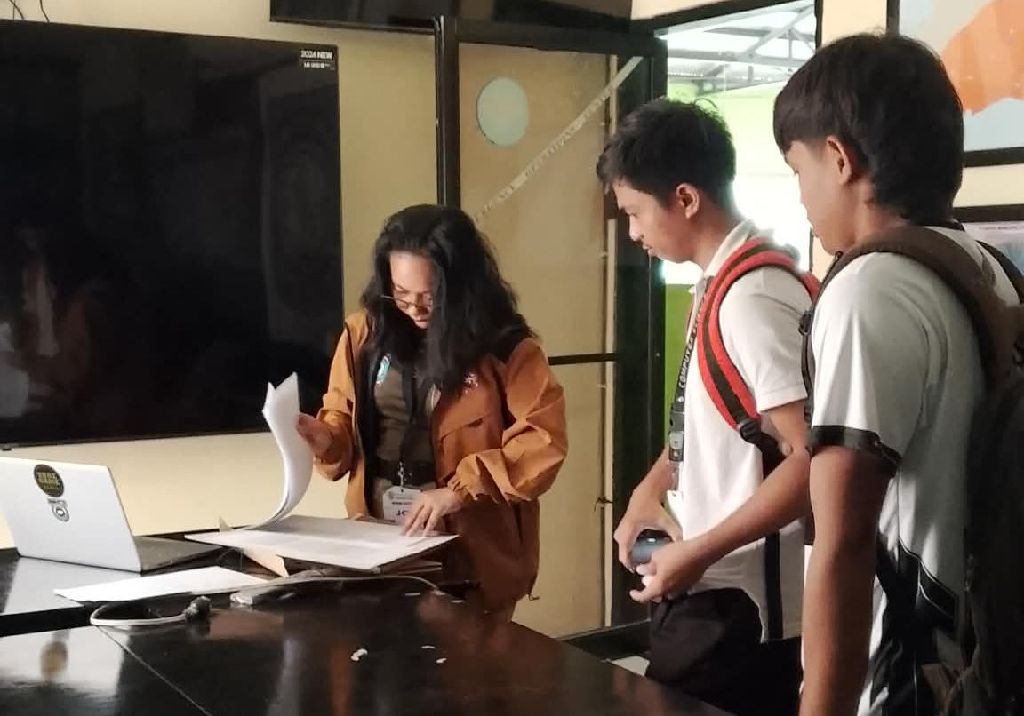
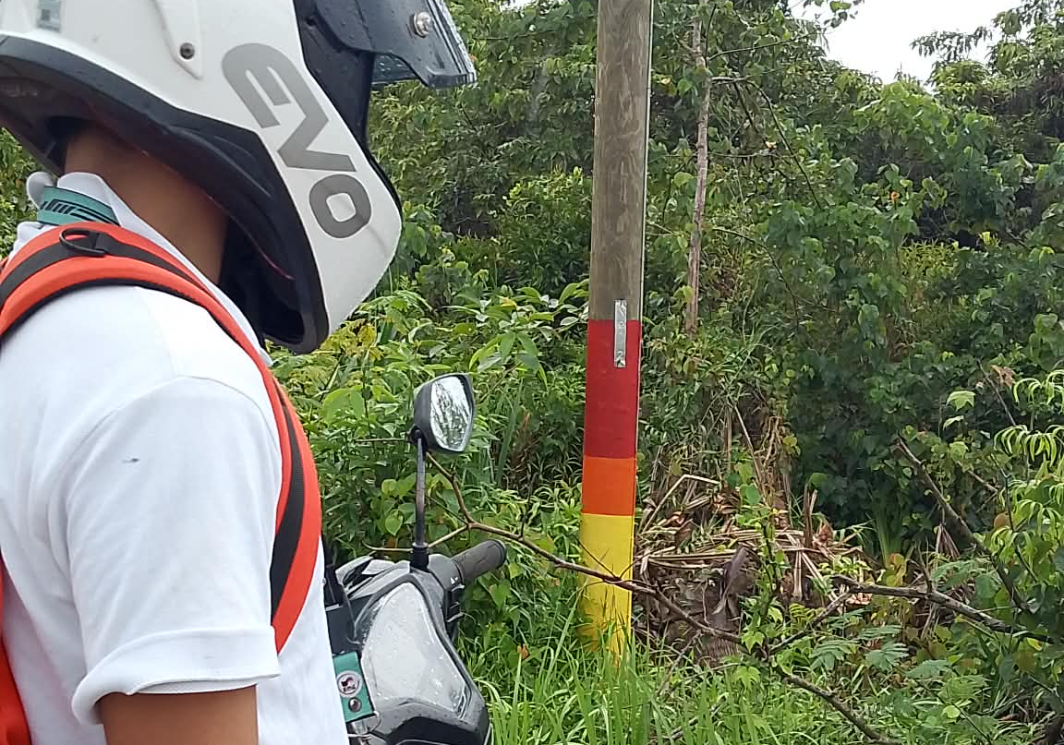
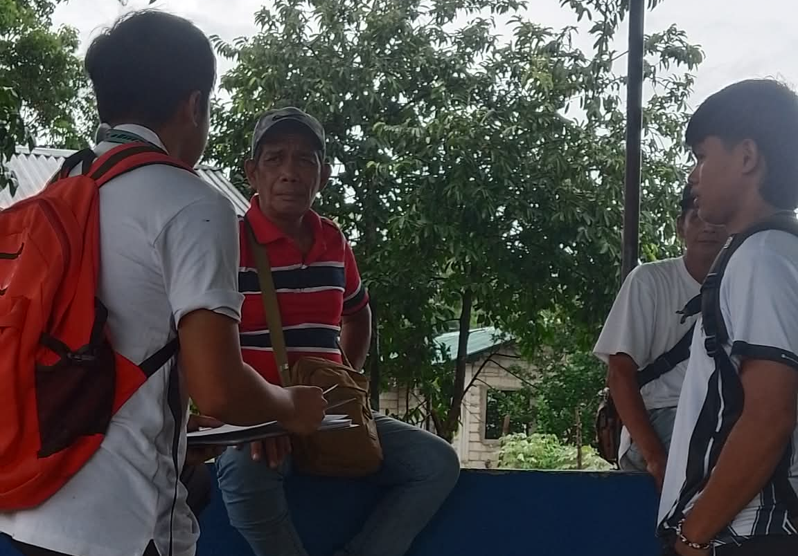
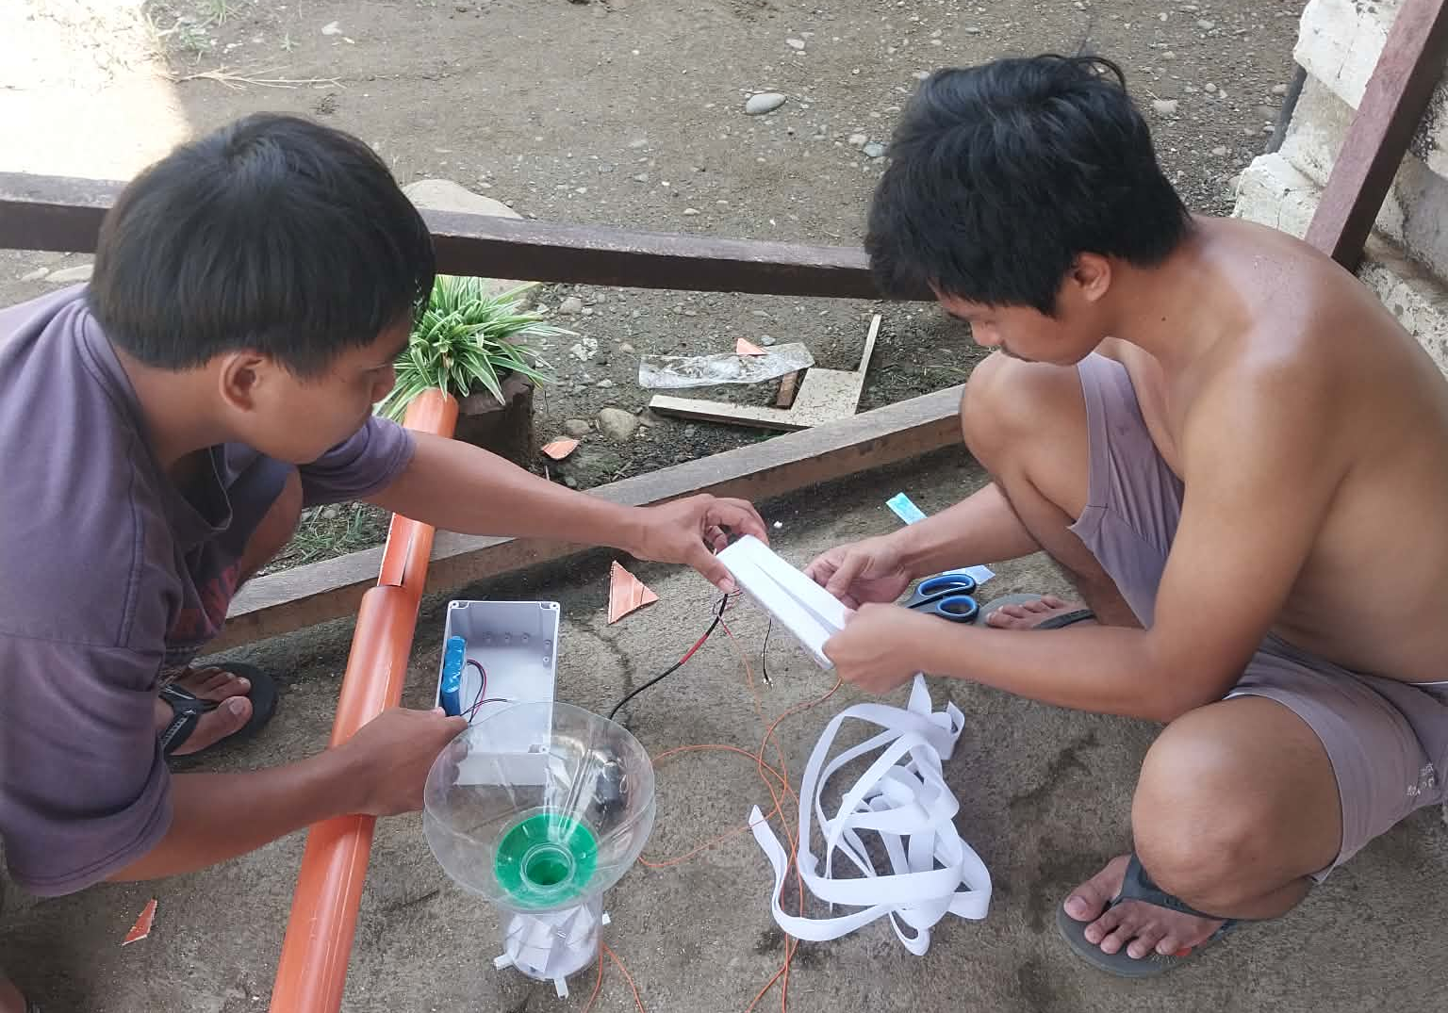
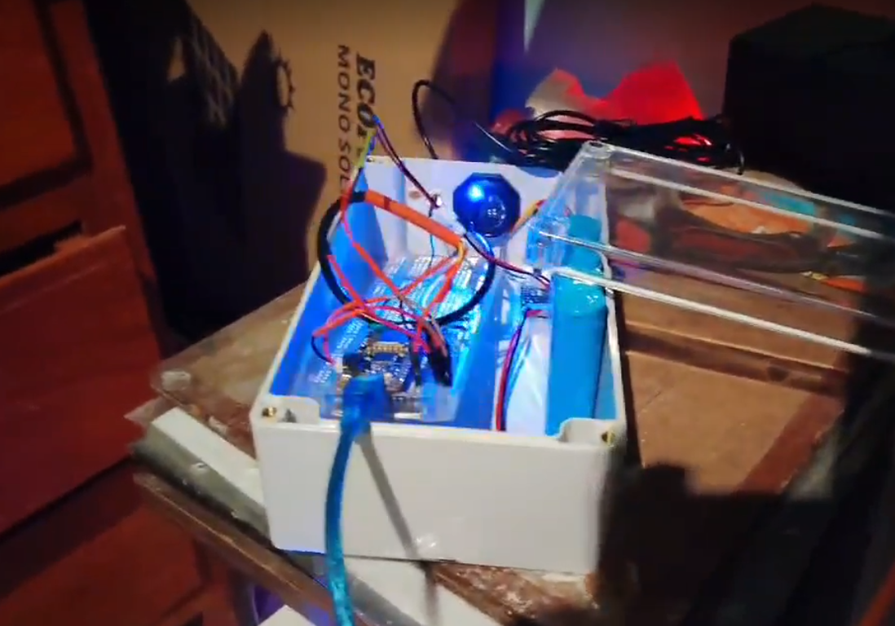
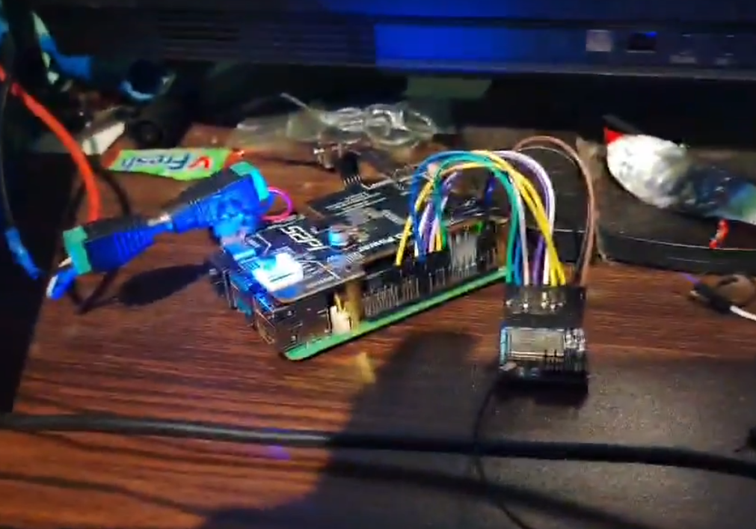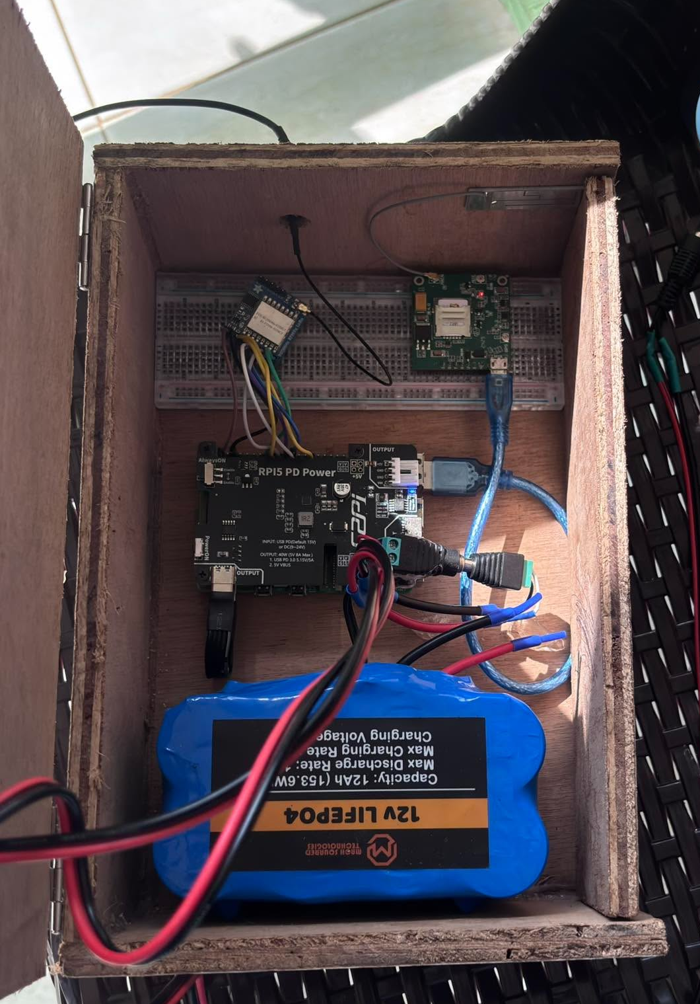
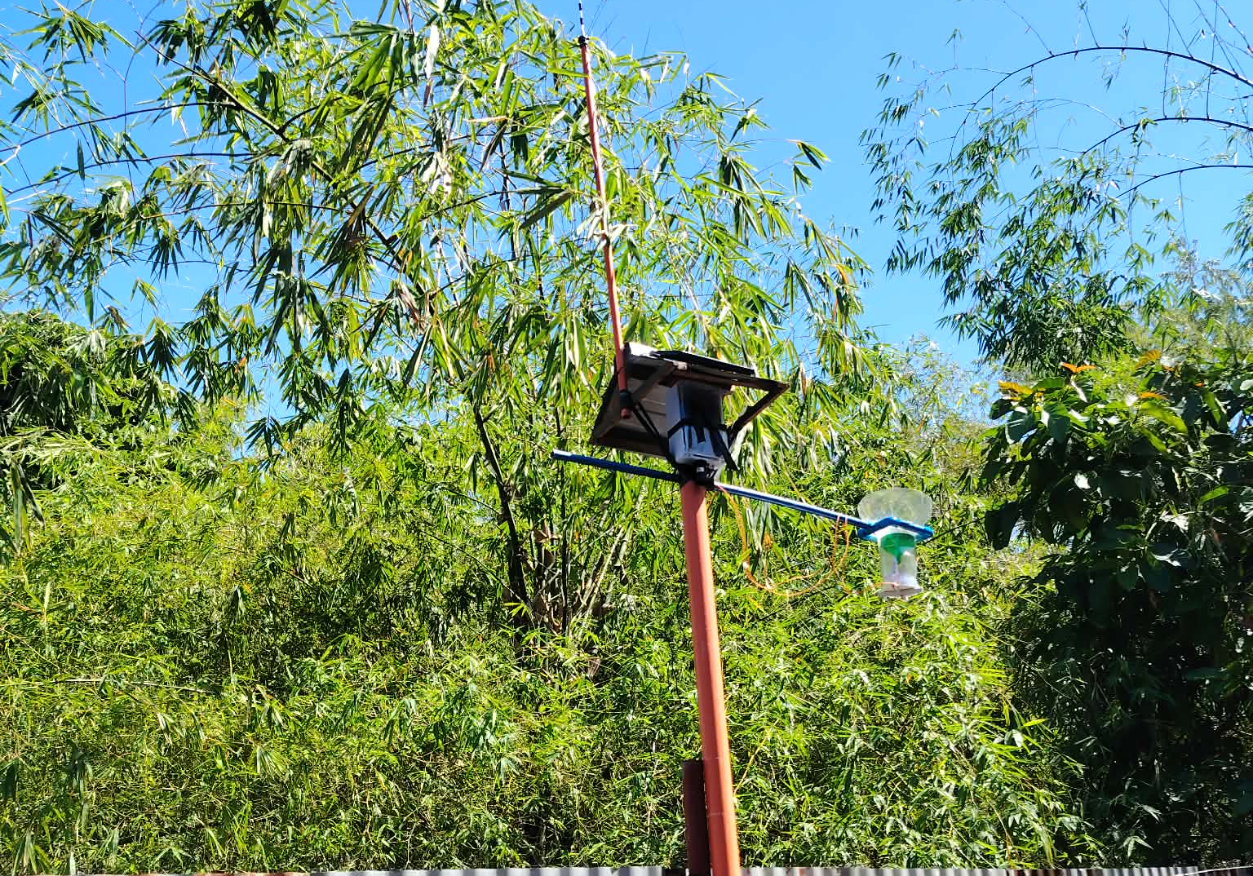
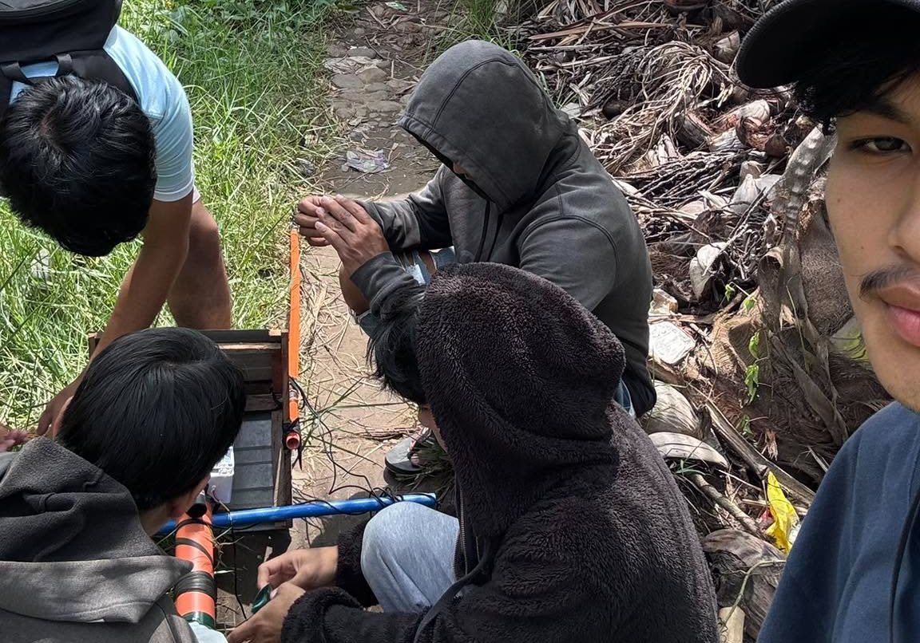
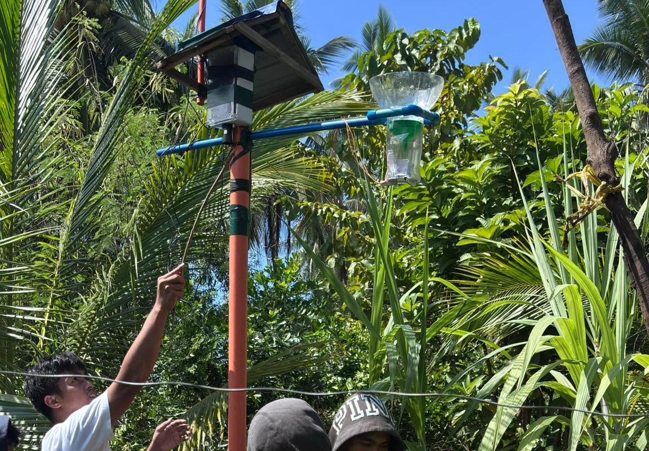
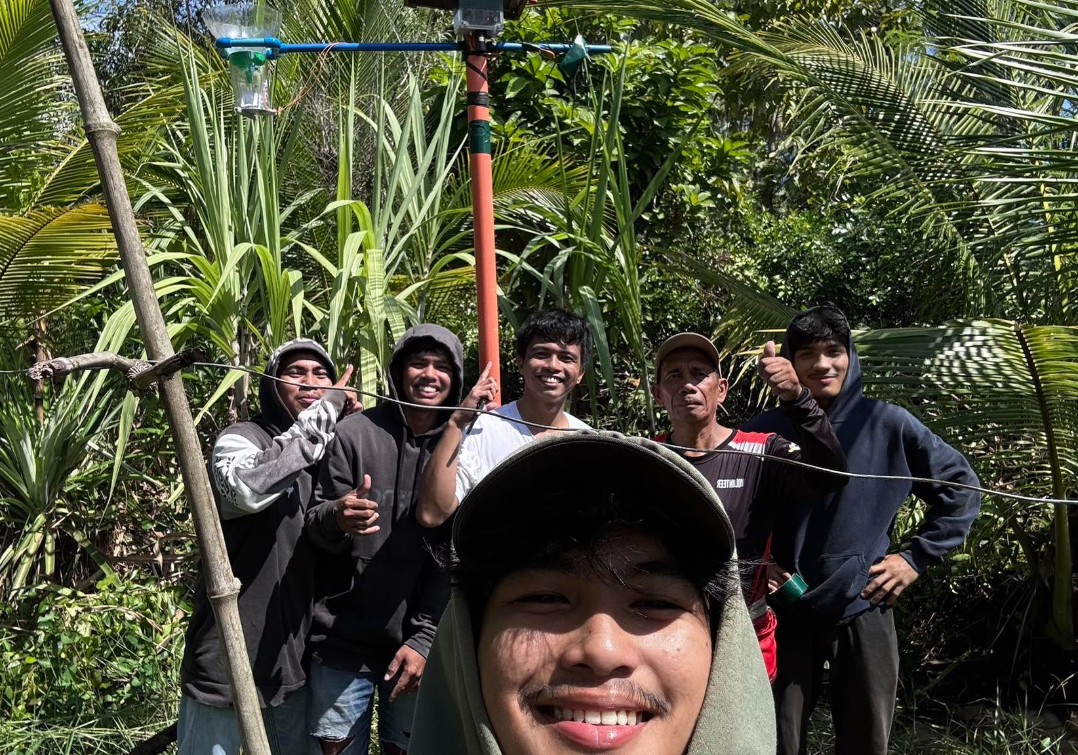
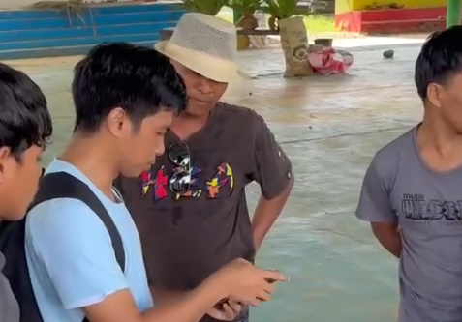
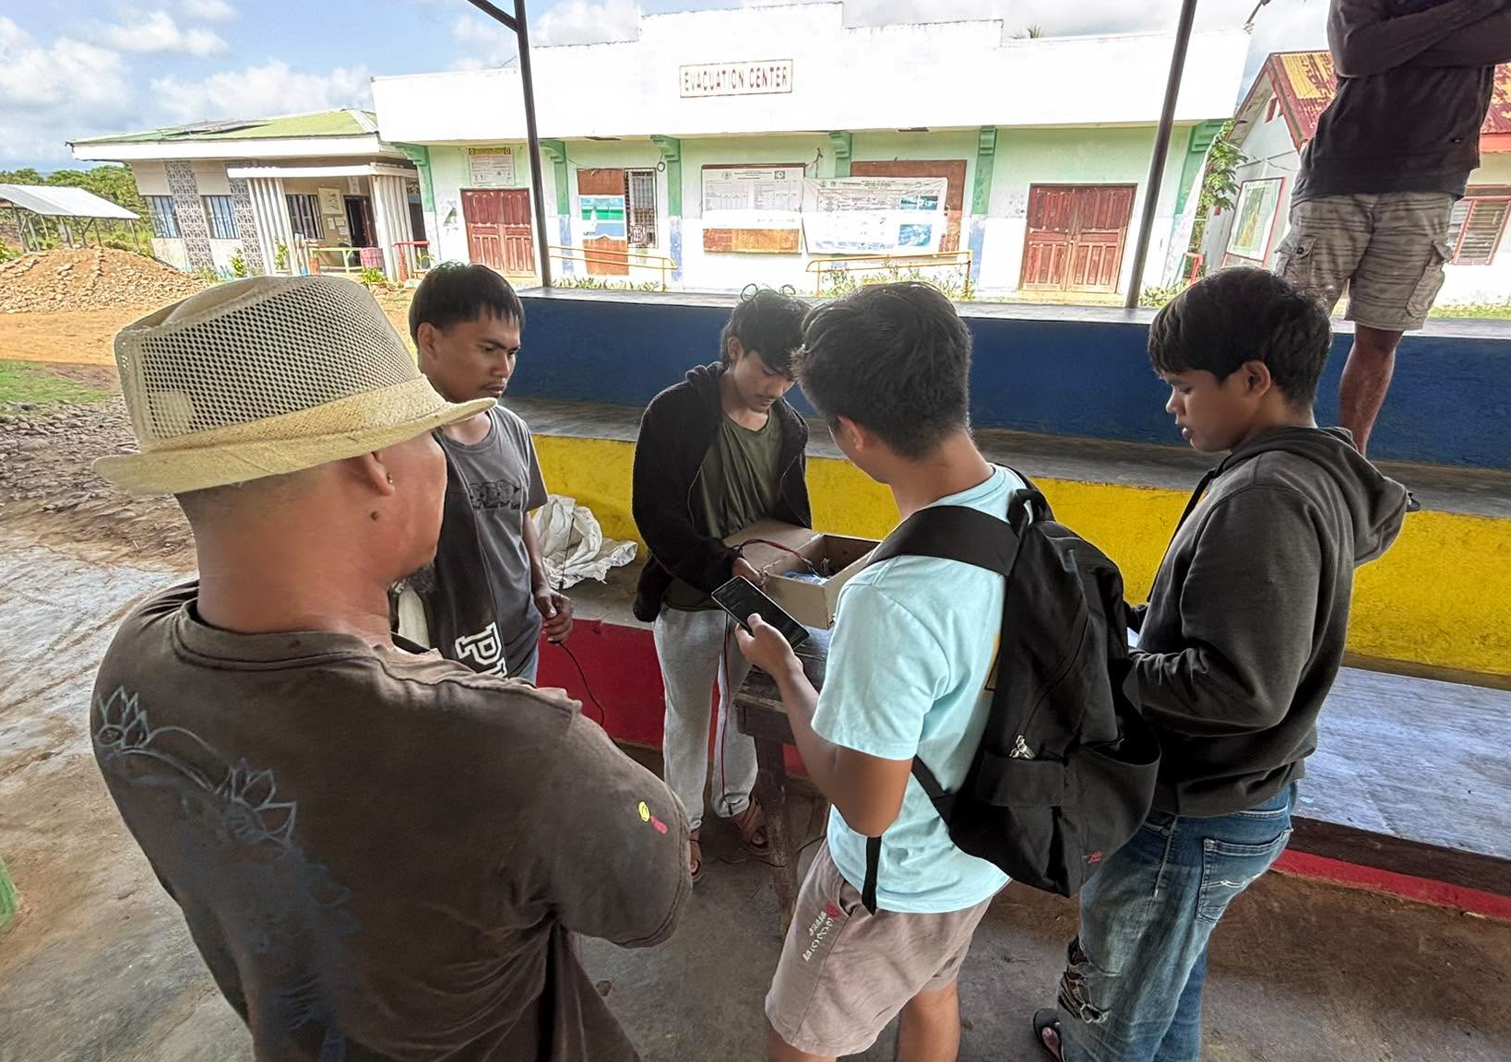
‘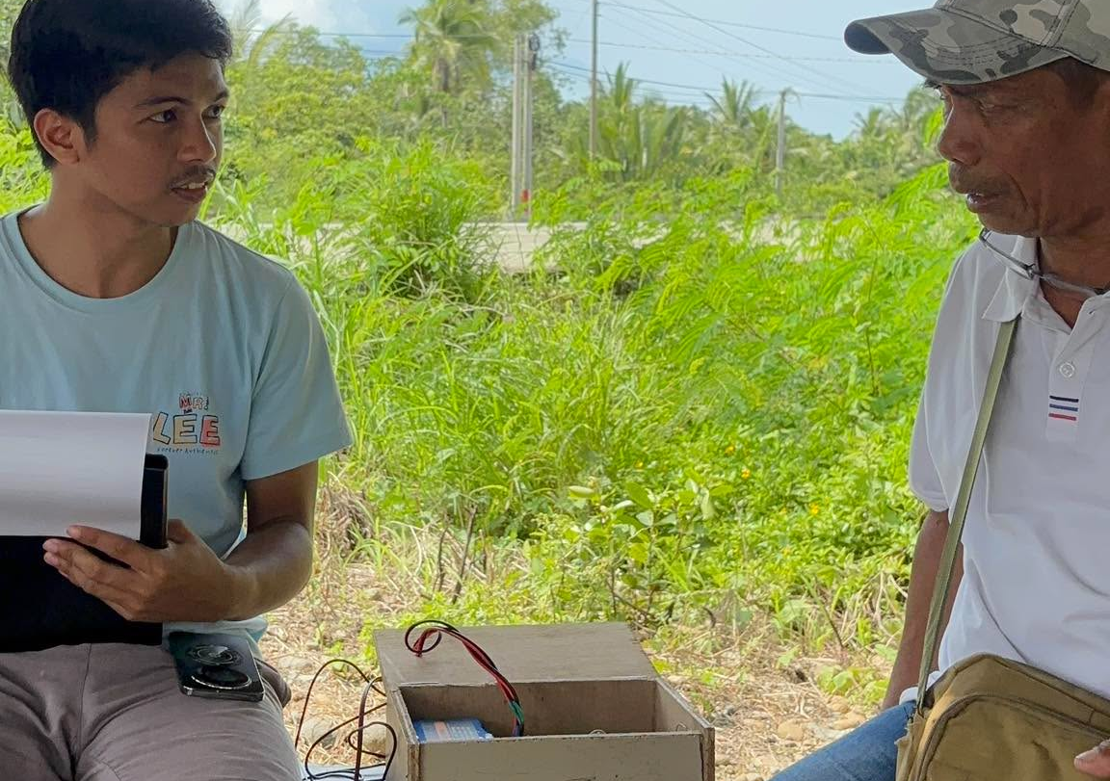
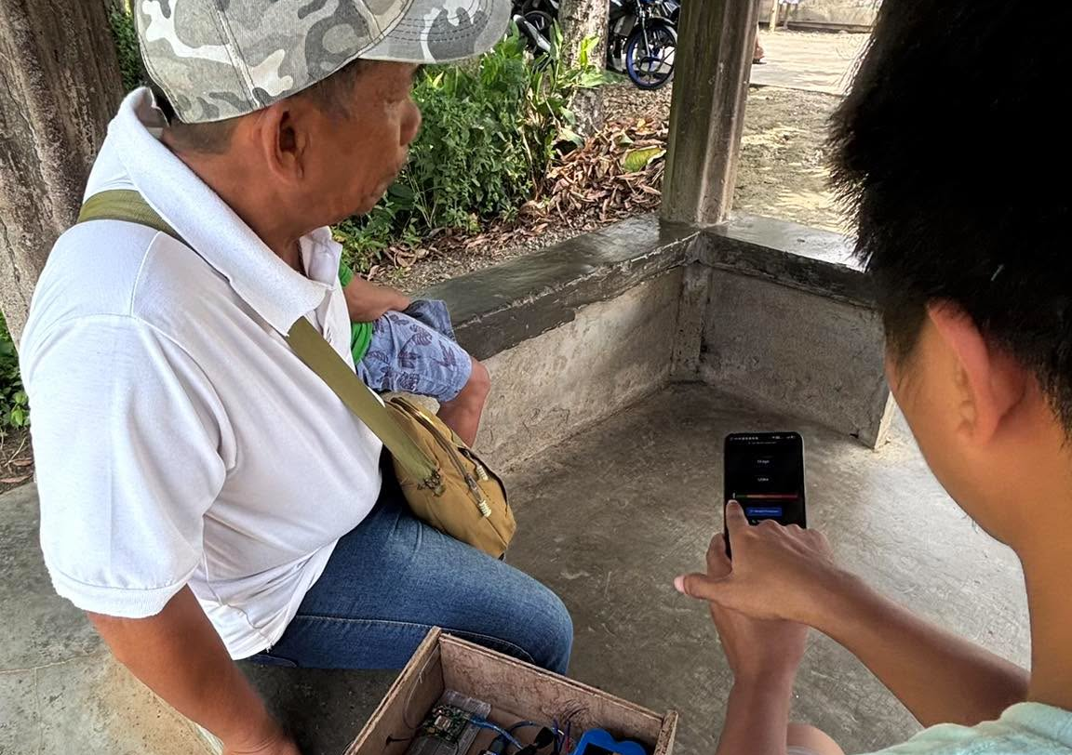

Appendix E
LETTERS AND OTHER COMMUNICATIONS

Appendix F
GRAMMARIAN CERTIFICATION

Appendix G
 |  | NATHANIEL S. BETITA  Brgy. PANACAN II, Narra, Palawan  Mobile #: 0994-017-6150
PERSONAL DATA:
Age: | 25
Sex: | Male
Birthday: | December 26, 2000
Height: | 5`5
Weight | 55
Religion: | The Church of Jesus Christ of Latter-day Saints
Nationality: | Filipino
Parents: | William T. Betita  Arlene S. Betita
EDUCATIONAL BACKGROUND:
Tertiary: | Palawan State University  NIA-MBBRIS Compound, Narra, Palawan  Bachelor of Science in Computer Science
Senior High: | Narra National High School  Narra, Palawan
Junior High: | Narra National High School  Narra, Palawan
Elementary: | Narra Pilot School  Narra, Palawan
CURRICULUM VITAE
P A L A W A N S T A T E U N I V E R S I T Y – N A R R A C A M P U S

